**Database Management**

# Introduction

* **CLO1 & CLO2: Final Exam (50%)**

Lecture

* **Introduction to Database**
* **Database management system and functions**
* **Database environment**
* **Relational database concept**
* **Data modeling with entity relationship diagram**
* **Database Normalization**
* **Structure Query Language (SQL)**
* **CLO3 : Group Assignment (50%)**

Tutorial / Case Study

* **Database design and modeling**
* **Database redundancy control**
* **Relational schema mapping**
* **Database management tools and functions**
* **Define a database using Data Definition Language (DDL) Manipulate a database using Data Manipulation Language (DML)**
* **Analyze a case study and implement a database solution**

I’m trying to sell my sem 2 notes and assignments answers, if you’re interested please let me know. If any of your friends want to buy you can suggest them to buy it from me I’ll give some commission if your friends refer your name and phone number to me.

I’m selling it for a fairly cheap price of RM20 per notes/assignments ans. (btw it is much better to make notes in ms word so that you can see all the topics in stead of opening many ppt at once)

(and buying it from me can save you weeks of jotting down notes and give a brief understanding of assignments)

Oh it’s okay maybe next time, thank you for your time 😊.

# Chapter 1: Introduction to Database

* Data vs Information
* Database vs DBMS
* Types of database

## **Data vs Information**

* Data:
  + Raw facts; building blocks of information.
  + Unprocessed information
* Information:
  + Data processed to reveal meaning.
* Accurate, relevant, and timely information is key to good decision making
* Good decision making is the key to survival in a global environment

Watch to understand more:

<https://www.youtube.com/watch?v=TqrtH7LMDFk>

## **Database vs DBMS (Database Management System)**

* Database—shared, integrated computer structure that stores:
  + End user data (raw facts)
  + Metadata (data about data)
* DBMS (database management system):
  + Collection of programs that manages database structure and controls access to data
  + Possible to share data among multiple applications or users
  + Makes data management more efficient and effective

Watch to understand more.

<https://www.youtube.com/watch?v=X7v0O8yiUuY>

Advantages of DBMS

* End users have better access to more and better-managed data
  + Promotes integrated view of organization’s operations
  + Probability of data inconsistency is greatly reduced
  + Possible to produce quick answers to ad hoc queries

## **Types of Databases**

* Single-user:
  + Supports only one user at a time
* Desktop:
  + Single-user database running on a personal computer
* Multi-user:
  + Supports multiple users at the same time
* Workgroup:
  + Multi-user database that supports a small group of users or a single department
* Enterprise:
  + Multi-user database that supports a large group of users or an entire organization

Can be classified by location:

* Centralized:
  + Supports data located at a single site
* Distributed:
  + Supports data distributed across several sites

Can be classified by use:

* Transactional (or production):
  + Supports a company’s day-to-day operations
* Data warehouse:
  + Stores data used to generate information required to make tactical or strategic decisions
  + Often used to store historical data
  + Structure is quite different

## **Summary of Main Points**

* Data are raw facts, information is processed data to reveal meaning
* Database store shared, integrated data.
* DBMS is a collection of programs that manages database structure and controls access to data.
* Database can be classified by usage or location

## **Questions**

1. **What is the difference between data and information?**
2. **Describe the difference between database and DBMS.**
3. **Briefly explain 3 types of databases.**
4. **What are the advantages of DBMS?**
5. Difference between Data and Information:

Data refers to raw facts, figures, or symbols that have no meaning on their own. It is unorganized and lacks context. For example, a list of numbers or characters.

Information, on the other hand, is processed, organized, and meaningful data that provides context and relevance. It is the result of analyzing, interpreting, and summarizing data to make it useful for decision-making or understanding. For example, a graph showing trends in sales over time.

1. Difference between Database and DBMS:

Database: A database is an organized collection of structured data that is stored electronically in a computer system. It consists of tables, records, and fields, and is designed to efficiently manage and retrieve information.

DBMS (Database Management System): DBMS is software that provides an interface for users to interact with the database. It facilitates the creation, manipulation, and management of databases, including tasks such as data entry, querying, updating, and deletion. DBMS also ensures data integrity, security, and concurrency control.

1. Three Types of Databases:

Relational Databases: Relational databases organize data into tables with rows and columns, where each row represents a record and each column represents a field or attribute. They use structured query language (SQL) for querying and managing data. Examples include MySQL, Oracle Database, and Microsoft SQL Server.

* Single-user:
  + Supports only one user at a time
* Desktop:
  + Single-user database running on a personal computer
* Multi-user:
  + Supports multiple users at the same time
* Workgroup:
  + Multi-user database that supports a small group of users or a single department
* Enterprise:
  + Multi-user database that supports a large group of users or an entire organization

1. Advantages of DBMS:

End users have better access to more and better-managed data.

* Promotes integrated view of organization’s operations.
* Probability of data inconsistency is greatly reduced.
* Possible to produce quick answers to ad hoc queries.

# Chapter 2: File System

* File System
* Problems with file system
* Data redundancy
* Database environment components
* DBMS functions

## **Why is database design important?**

* Defines the database’s expected use.
* Different approach needed for different types of databases.
* Avoid redundant data.
* Poorly designed database generates errors 🡪 leads to bad decisions 🡪 can lead to failure of organization.

## **History: Files and File System**

* Managing data with file systems is obsolete.
  + Understanding file system characteristics makes database design easier to understand
  + Awareness of problems with file systems helps prevent similar problems in DBMS
  + Knowledge of file systems is helpful if you plan to convert an obsolete file system to a DBMS

Manual File systems:

* Collection of file folders kept in file cabinet
* Organization within folders based on data’s expected use (ideally logically related)
* System adequate for small amounts of data with few reporting requirements
* Finding and using data in growing collections of file folders became time-consuming and cumbersome

Conversion from manual to computer system:

* Could be technically complex, requiring hiring of data processing (DP) specialists
* Resulted in numerous “home-grown” systems being created
* Initially, computer files were similar in design to manual files (see Figure 1.3)

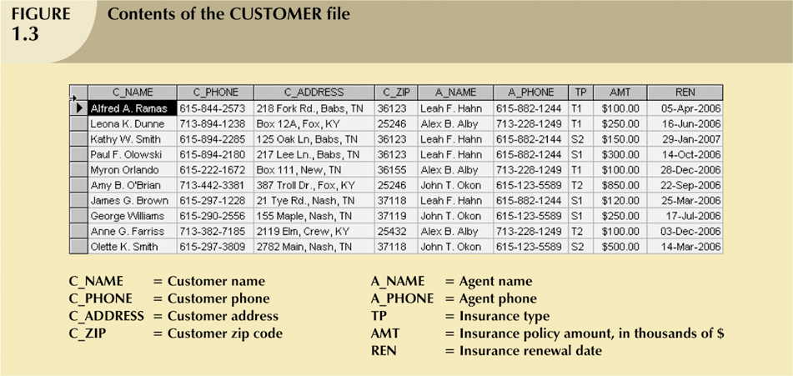

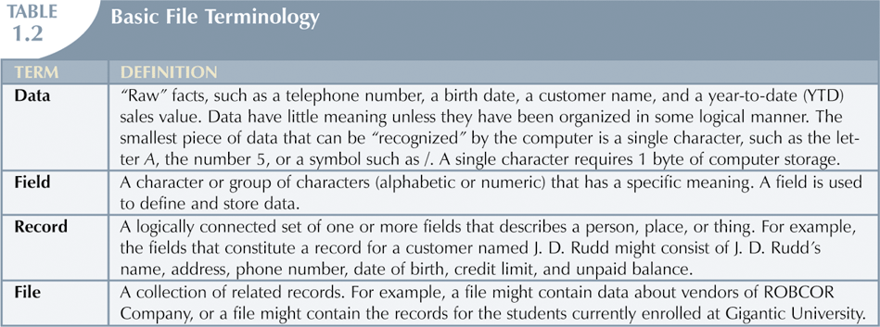

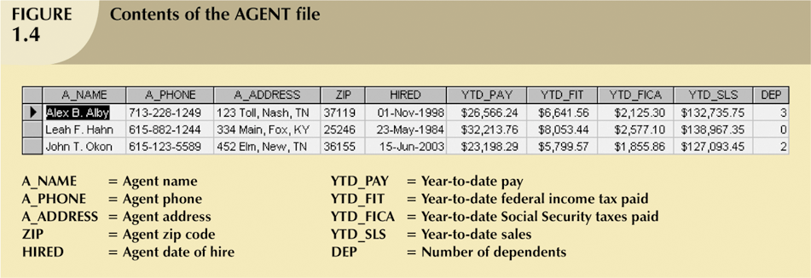

* As number of databases increased, small file system evolved.
* Each file used its own application programs.
* Each file was owned by individual or department who commissioned its creation.

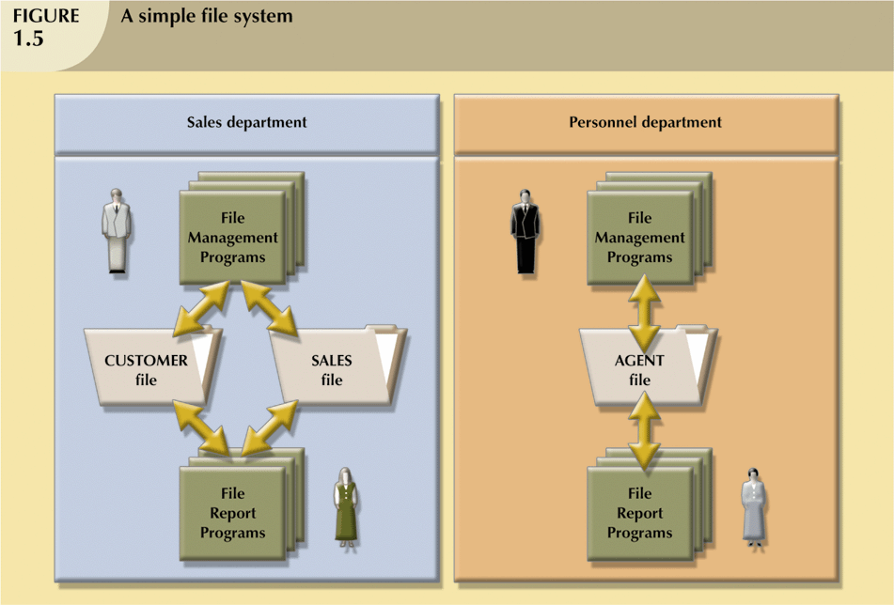

## **Problems with File System Data Management**

* Time-consuming, high-level activity
* As number of files expands, system administration becomes difficult
* Making changes in existing file structure is difficult
* File structure changes require modifications in all programs that use data in that file
  + Modifications are likely to produce errors, requiring additional time to “debug” the program
  + Security features hard to program and therefore often omitted

## **Data Redundancy**

* Data redundancy results in data inconsistency
  + Different and conflicting versions of the same data appear in different places
* Errors more likely to occur when complex entries are made in several different files and/or recur frequently in one or more files
* Data anomalies develop when required changes in redundant data are not made successfully
* Repeated Data is unnecessary
* Data redundancy can cause inconsistency, make conflict such like data anomaly

## **Types of anomalies**

* Update anomalies
  + Occur when changes must be made to existing records.
* Insertion anomalies
  + Occur when entering new records.
* Deletion anomalies
  + Occur when deleting records.

## **Database System**

* Problems inherent in file systems make using a database system desirable
* File system
  + Many separate and unrelated files
* Database
  + Logically related data stored in a single logical data repository

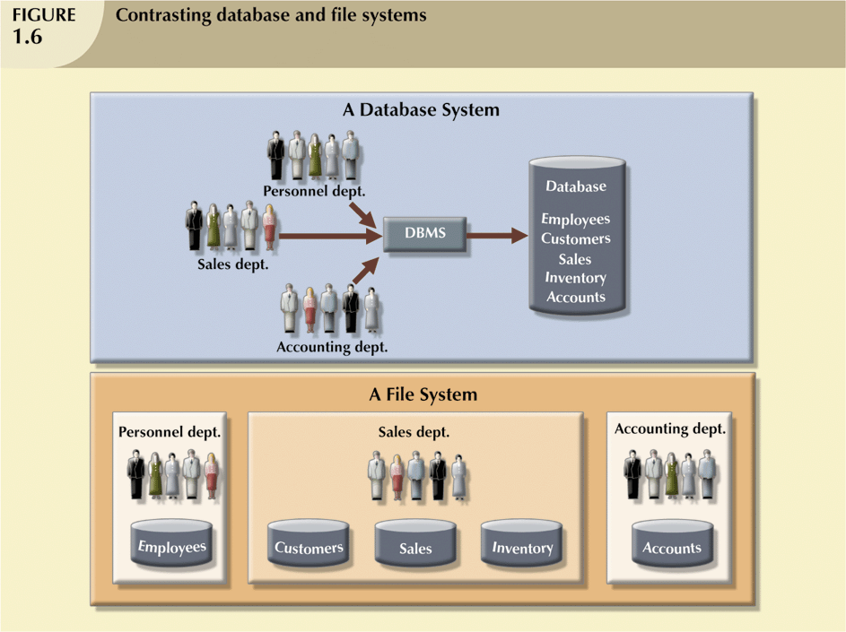

## **Database System Environment**

* Database system is composed of five main parts:
  + Hardware
  + Software
    - Operating system software
    - DBMS software
    - Application programs and utility software
  + People
  + Procedures
  + Data

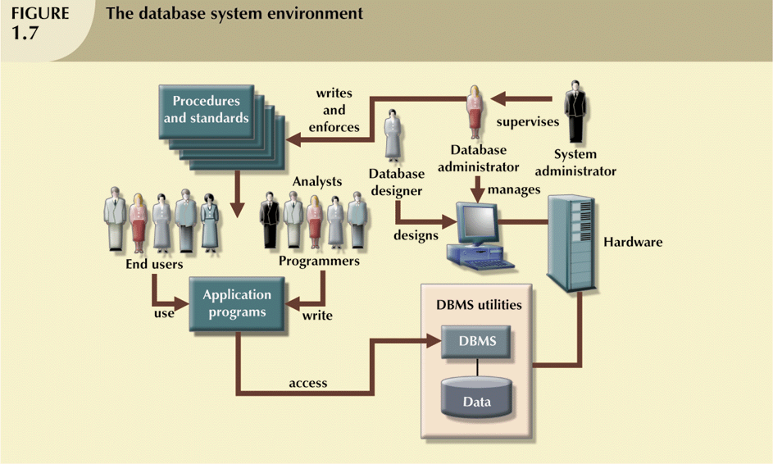

## **DBMS Functions**

* DBMS performs functions that guarantee integrity and consistency of data
  + Data dictionary management
    - defines data elements and their relationships
  + Data storage management
    - stores data and related data entry forms, report definitions, etc.
  + Data transformation and presentation
    - translates logical requests into commands to physically locate and retrieve the requested data
  + Security management
    - enforces user security and data privacy within database
  + Multiuser access control
    - uses sophisticated algorithms to ensure multiple users can access the database concurrently without compromising the integrity of the database
  + Backup and recovery management
    - provides backup and data recovery procedures
  + Data integrity management
    - promotes and enforces integrity rules
  + Database access languages and application programming interfaces
    - provide data access through a query language
  + Database communication interfaces
    - allow database to accept end-user requests via multiple, different network environments

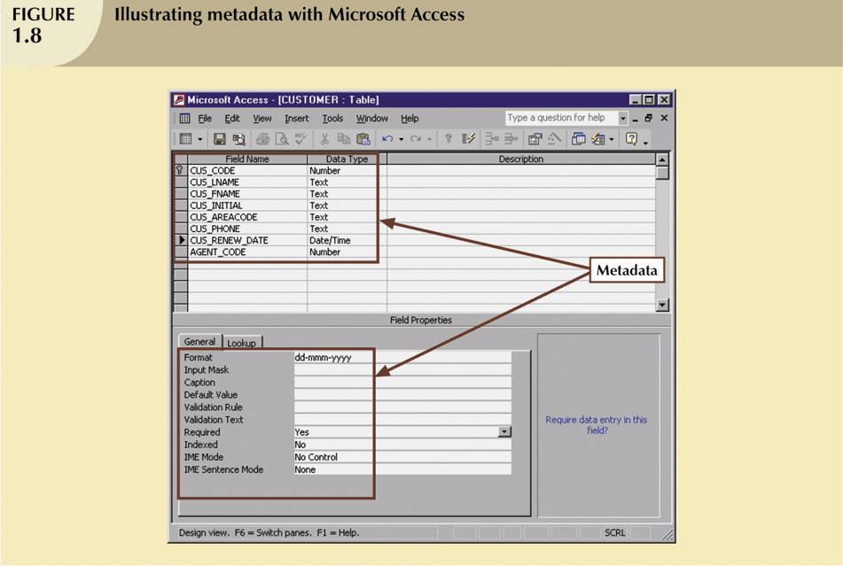

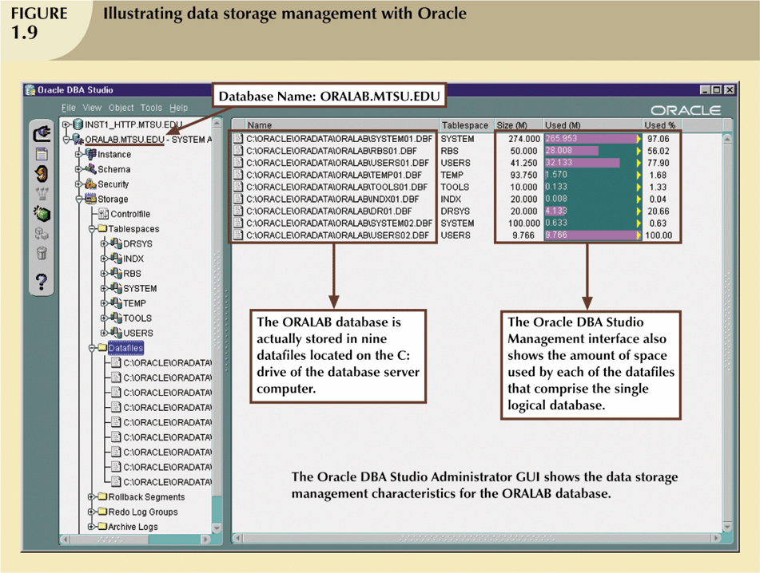

## **Summary Of Main Points**

* Databases were preceded by file systems.
* Limitations of file system data management:
  + requires extensive programming
  + system administration complex and difficult
  + making changes to existing structures is difficult
  + security features are likely to be inadequate
  + independent files tend to contain redundant data
* DBMS’s were developed to address file systems’ inherent weaknesses

## **Questions**

* + Explain what is file system and its problems
  + Understand data redundancy
  + State the types of data anomaly
  + List the components in database environment
  + Describe DBMS functions

What are the disadvantages of file based system?

What is data redundancy?

Explain different types of data anomaly.

Describe 3 functions of DBMS.

# Chapter 3: Data Model

* Data model
* Business rules
* Relational model
* Entity Relationship Model

## **The importance of Data Models**

* Data models
  + Relatively simple representations, usually graphical, of complex real-world data structures
  + Facilitate interaction among the designer, the applications programmer, and the end user
* End-users have different views and needs for data
* Data model organizes data for various users

## **Data Model Basic Building Blocks**

* Entity - anything about which data are to be collected and stored
* Attribute - a characteristic of an entity
* Relationship - describes an association among entities
  + One-to-many (1:M) relationship
  + Many-to-many (M:N or M:M) relationship
  + One-to-one (1:1) relationship
* Constraint - a restriction placed on the data

## **Business Rules**

* Brief, precise, and unambiguous descriptions of a policies, procedures, or principles within a specific organization
* Apply to any organization that stores and uses data to generate information
* Description of operations that help to create and enforce actions within that organization’s environment
* Must be rendered in writing
* Must be kept up to date
* Sometimes are external to the organization
* Must be easy to understand and widely disseminated
* Describe characteristics of the data as viewed by the company

Discovering Sources

Sources of Business Rules:

* Company managers
* Policy makers
* Department managers
* Written documentation
  + Procedures
  + Standards
  + Operations manuals
* Direct interviews with end users
* Generally, nouns translate into entities
* Verbs translate into relationships among entities
* Relationships are bi-directional

## **The Evolition of Data Models**

* Hierarchical
* Network
* Relational
* Entity relationship

## **Hierarchical Data Model**

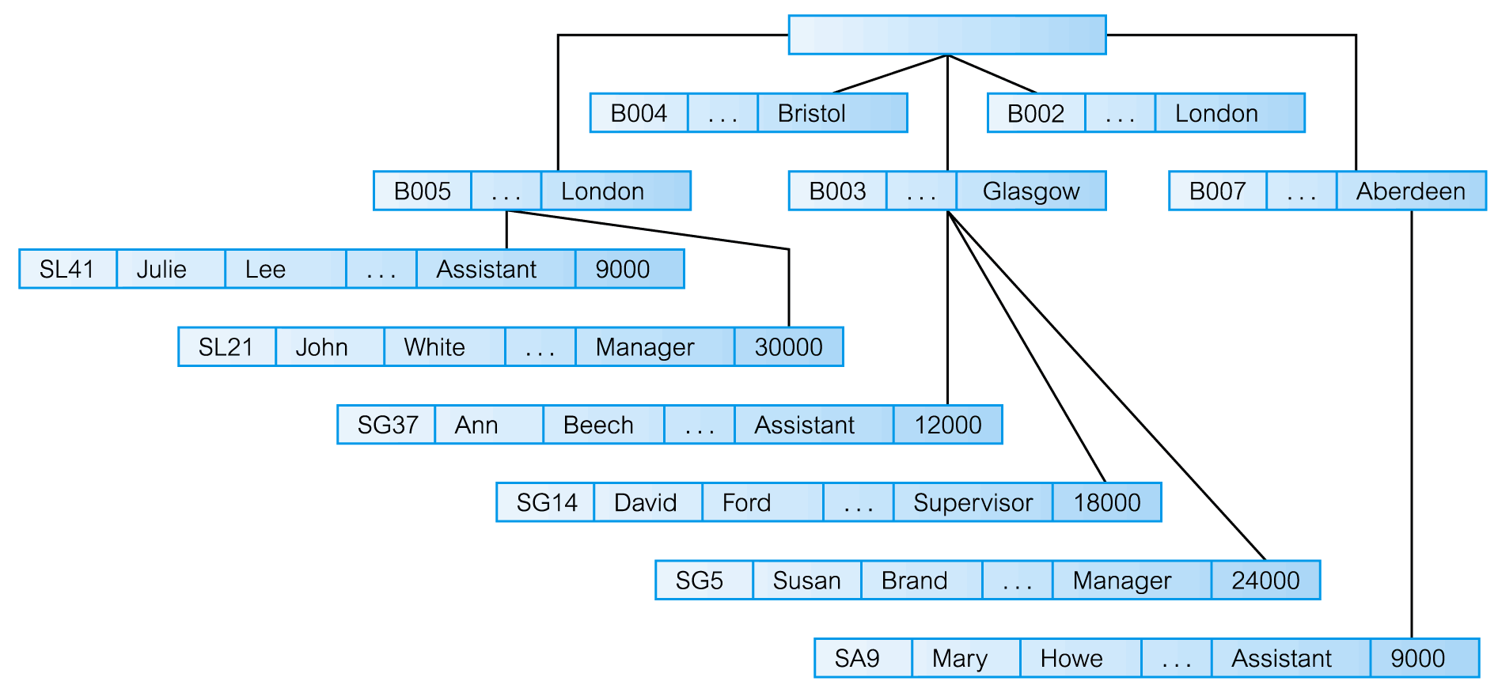

## **Network Model**

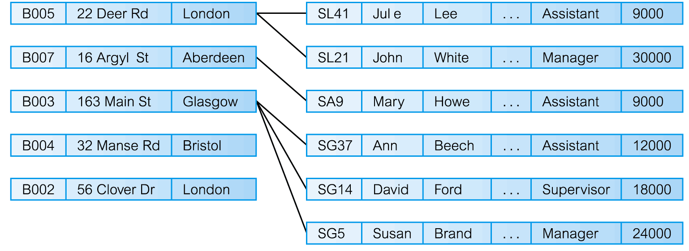

## **Relational Model**

* Developed by Codd (IBM) in 1970
* Considered ingenious but impractical in 1970.
* Conceptually simple
* Computers lacked power to implement the relational model.
* Today, microcomputers can run sophisticated relational database software.
* Table (relations)
  + Matrix consisting of a series of row/column intersections.
  + Related to each other through sharing a common entity characteristic.
* Relational diagram
  + Representation of relational database’s entities, attributes within those entities, and relationships between those entities
* Relational Table
  + Stores a collection of related entities.
    - Resembles a file.
* Relational table is purely logical structure.
  + How data are physically stored in the database is of no concern to the user or the designer
  + This property became the source of a real database revolution.

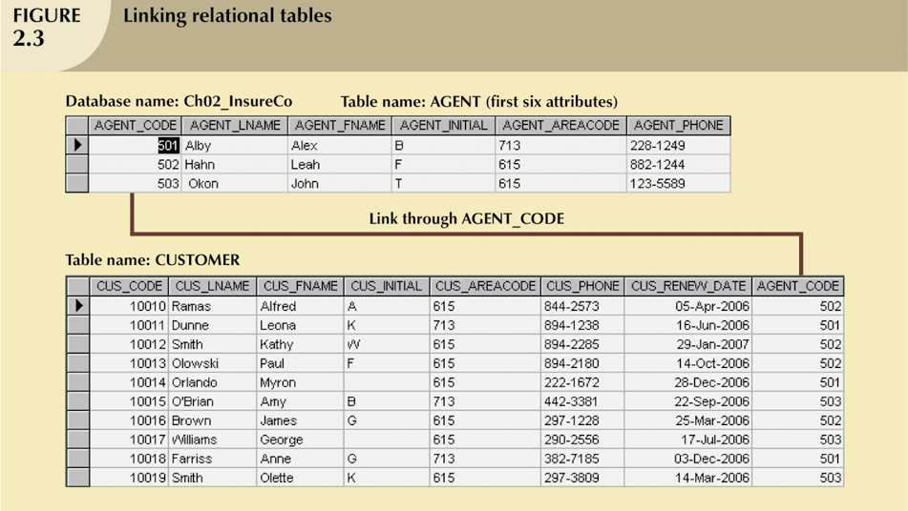

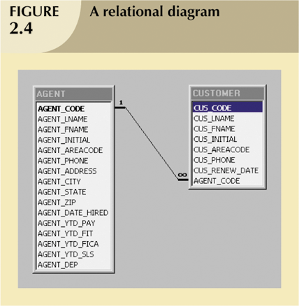

## **Entity Relationship Model**

* Widely accepted and adapted graphical tool for data modeling.
* Introduced by Chen in 1976.
* Graphical representation of entities and their relationships in a database structure.
* Entity relationship diagram (ERD)
  + Uses graphic representations to model database components.
  + Entity is mapped to a relational table.
* Entity instance (or occurrence) is row in table.
* Entity set is collection of like entities.
* Connectivity label types of relationships
  + Diamond connected to related entities through a relationship line.

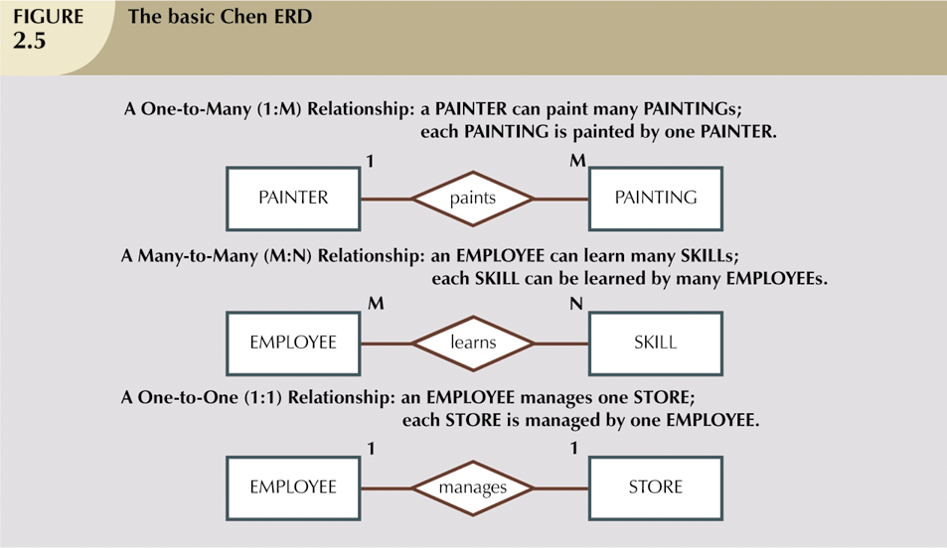

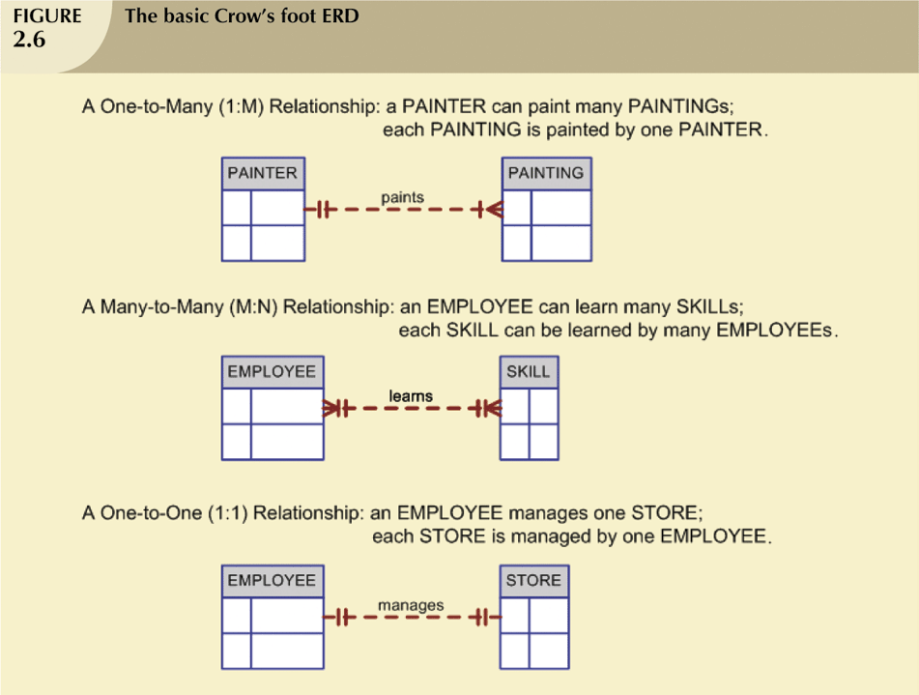

## **Summary**

* Data models are simple representations, usually graphical, of complex real-world data structures.
* Business rules are brief, precise, and unambiguous descriptions of policies, procedures, or principles within a specific organization.
* Entity relationship models are graphical representation of entities and their relationships in a database structure.

## **Questions**

1. What is data model?
2. What is the source of business rules?
3. What is entity relationship model?

# Chapter 4: Relational Database

* Relational table
* Relational model components
* Data integrity rules
* Data dictionary

Topics to Master:

* + **Primary key**
  + **Foreign key**
  + **Candidate key**
  + **Attribute**
  + **Domain**

## **A Logical View of Data**

* Relational model
  + Enables programmers to view data logically rather than physically.
* Table
  + Has advantages of structural and data independence.
  + Resembles a file from conceptual point of view.
  + Easier to understand than its hierarchical and network database predecessors.

## **Tables and Characteristics**

* Table: two-dimensional structure composed of rows and columns
* Contains group of related entities = an entity set
  + Terms entity set and table are often used interchangeably.
* Table also called a relation because the relational model’s creator, Codd, used the term relation as a synonym for table
* Think of a table as a persistent relation:
  + A relation whose contents can be permanently saved for future use.

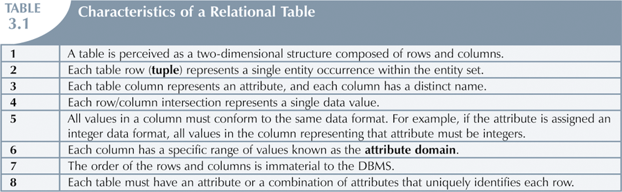

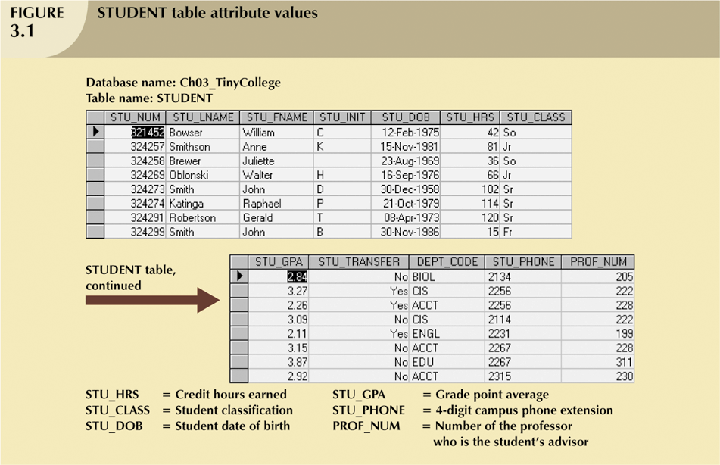

## **Keys**

* Consists of one or more attributes that determine other attributes.
* Primary key (PK) is an attribute (or a combination of attributes) that uniquely identifies any given entity (row)
* Key’s role is based on determination.
  + If you know the value of attribute A, you can look up (determine) the value of attribute B.
* Foreign key (FK)
  + An attribute whose values match primary key values in the related table.
* Referential integrity
  + FK contains a value that refers to an existing valid tuple (row) in another relation.

## **Candidate Key**

* A Candidate Key can be any column or a combination of columns that can qualify as unique key in database. There can be multiple Candidate Keys in one table. Each Candidate Key can qualify as Primary Key.

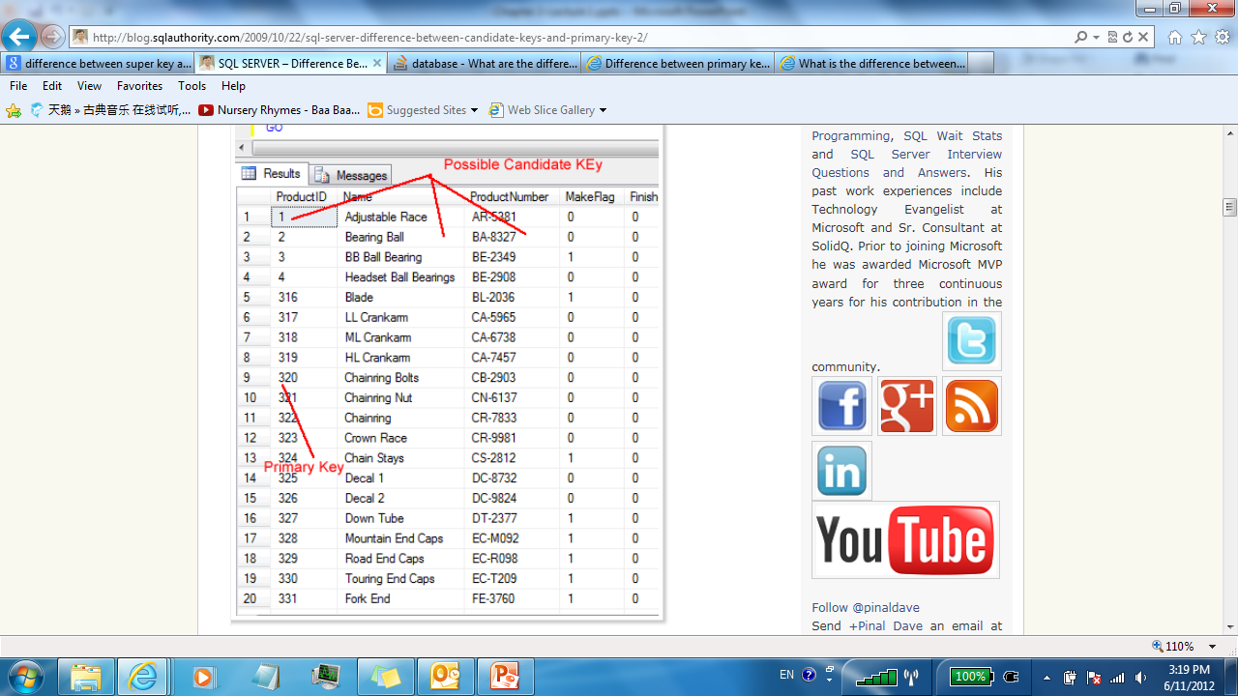

* Select a key that does not contain NULL.
* Select a key that is unique and does not repeat.
* Make sure that Primary Key does not keep changing.
* Nulls:
  + No data entry
  + Not permitted in primary key
  + Should be avoided in other attributes.
  + Can represent:
    - An unknown attribute value.
    - A known, but missing, attribute value.
    - A “not applicable” condition
  + Can create problems when functions such as COUNT, AVERAGE, and SUM are used.
  + Can create logical problems when relational tables are linked.
* Controlled redundancy:
  + Makes the relational database work
  + Tables within the database share common attributes that enable the tables to be linked together
  + Multiple occurrences of values in a table are not redundant when they are required to make the relationship work
  + Redundancy exists only when there is unnecessary duplication of attribute values

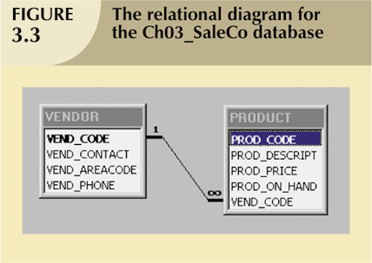

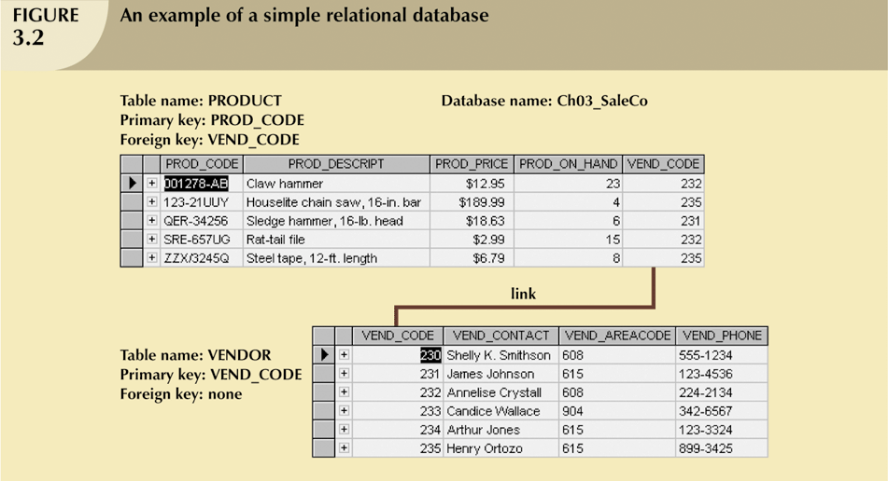

## **Integrity Rules**

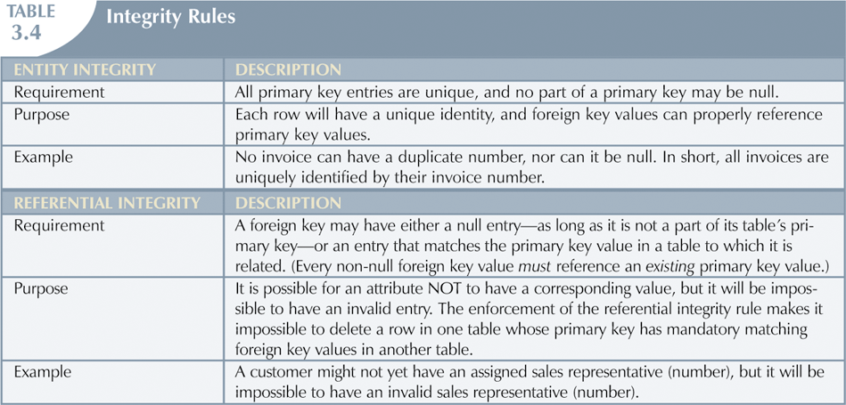

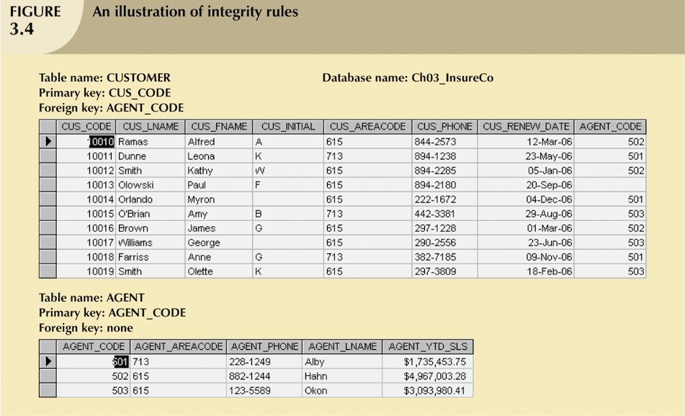

## **Data Dictionary and System Catalog**

* Data dictionary
  + Provides detailed accounting of all tables found within the user/designer-created database.
  + Contains (at least) all the attribute names and characteristics for each table in the system.
  + Contains metadata—data about data.
  + Sometimes described as “the database designer’s database” because it records the design decisions about tables and their structures.

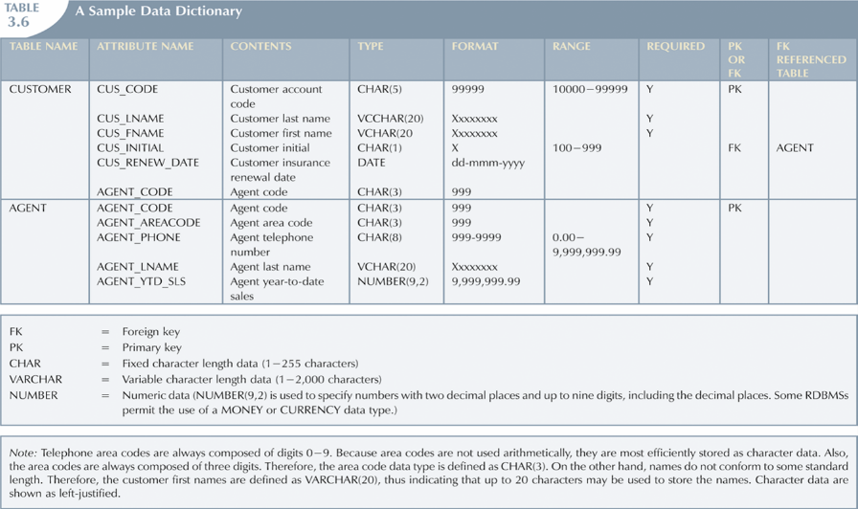

## **Questions**

1. What is a candidate key?
2. What is a primary key?
3. What is a foreign key?
4. What is entity integrity?
5. What is referential integrity?
6. What is data dictionary?

## **Summary**

* Tables are basic building blocks of a relational database
* Keys are central to the use of relational tables
* Keys define functional dependencies
  + Candidate key
  + Primary key
  + Secondary key
  + Foreign key

# Chapter 5: Relation Database

* Relationship within the relational model
  + 1:1
  + 1:M
  + M:N
* Resolving M:N relationship

## **Relationships within the Relational Database**

* 1:M relationship
  + Relational modeling ideal.
  + Should be the norm in any relational database design.
* 1:1 relationship
  + Should be rare in any relational database design.
* M:N relationships
  + Cannot be implemented as such in the relational model.
  + M:N relationships can be changed into two 1:M relationships

To understand more go to ppt lecturer slides week 5 (part2) @ slide 5. (I can’t write the notes down because there are mostly pictures in the lecture slides)

Cardinality is the numerical relationship between rows of one table and rows in another.

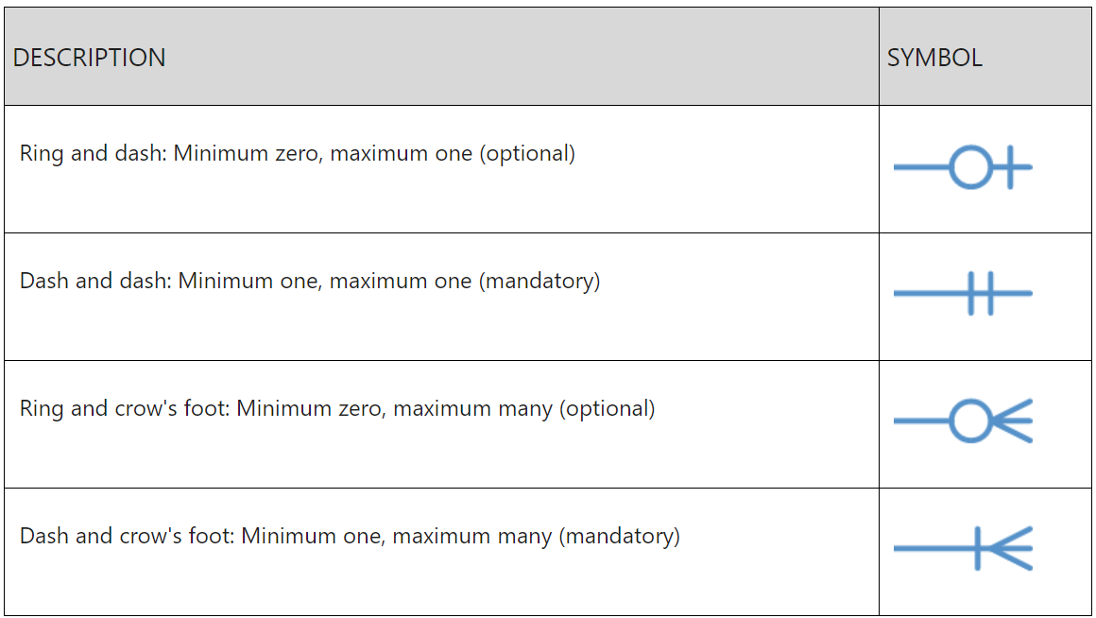

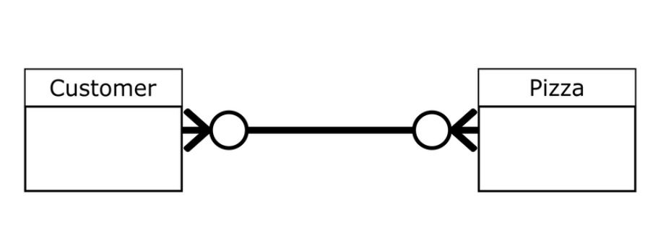

We have two entities – Customer and Pizza. These entities are linked together by a horizontal line with symbols/indicators/notations.

Let's begin with the notation on the left. It has the zero or many notation. This implies that a pizza can be ordered by none (optional) or many customers.

Similarly, the notation on the right side implies that a customer can order zero or many pizzas.

The cardinality here is the same for both entities. Zero is the minimum while many is the maximum.

The use cases for other crow's foot notation diagrams are the same as the ones in our examples. It all depends on the logic and what you're designing.

## **Data Redundancy**

* Data redundancy leads to data anomalies
  + Such anomalies can destroy the effectiveness of the database
* Foreign keys
  + Control data redundancies by using common attributes shared by tables
  + Crucial to exercising data redundancy control
* Sometimes, data redundancy is necessary

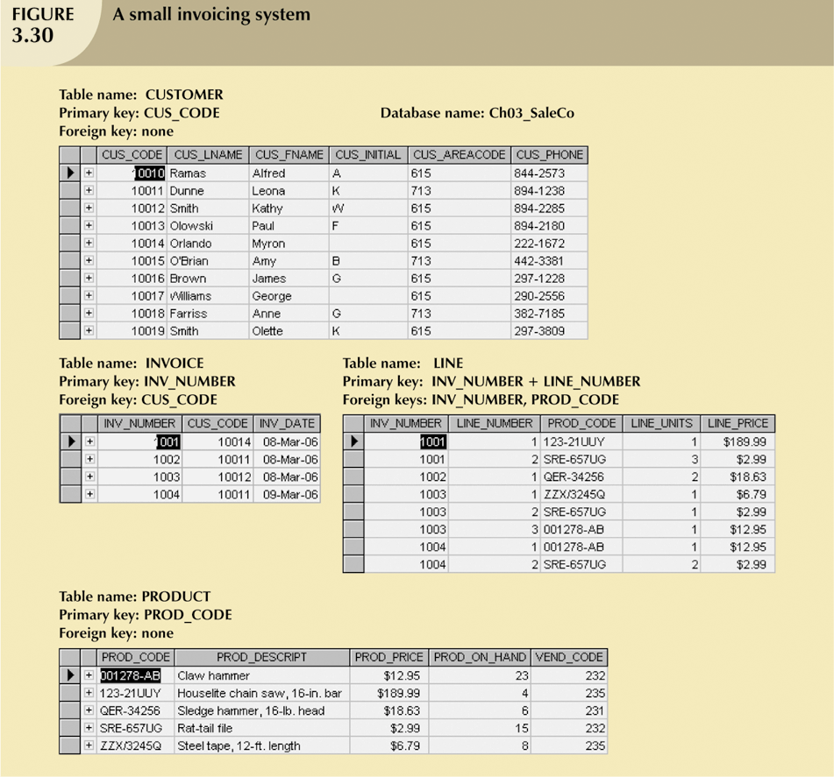

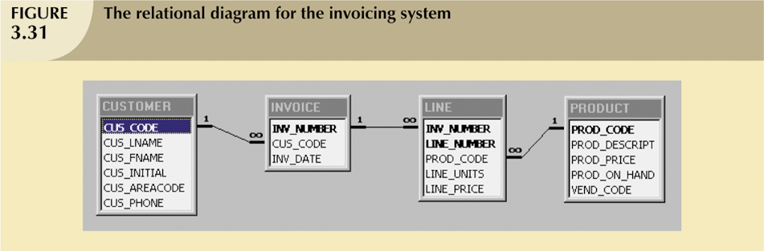

## **Q & A**

Provide 1 example for each type of relationships 1:1, 1:M, M:N.

Explain how to resolve M:N relationship using the example above.

1. 1:1 Relationship: This occurs when one record in a table is associated with exactly one record in another table, and vice versa.

Example: A table storing Student ID and another table storing a student's Fingerprint. Each student has a unique fingerprint, and each fingerprint belongs to only one student.

1. 1:M Relationship: This occurs when one record in a table is associated with multiple records in another table, but a record in the "many" table belongs to only one record in the "one" table.

Example: A table storing Course Information (course name, instructor) and another table storing Student Enrollment. Each course can have many students enrolled (many-to-one), but a student can only be enrolled in one course at a time (one-to-many).

1. M:N Relationship: This occurs when many records in one table can be associated with many records in another table.

Example: A table storing Students and another table storing Courses. Many students can enroll in many courses (many-to-many), and a course can have many students enrolled (many-to-many).

Resolving M:N Relationships:

An M:N relationship cannot be directly represented in a relational database with only one table. Here's how to resolve it using the example of students and courses:

Create a Junction Table: Introduce a new table to link the two existing tables. This table will have two foreign keys, one referencing the student table (student ID) and another referencing the course table (course ID).

Example: Create a table named Student_Course with two columns:

Student_ID (foreign key referencing Students table)

Course_ID (foreign key referencing Courses table)

This junction table establishes the many-to-many relationship between students and courses. A student can have multiple entries in the Student_Course table for each course they are enrolled in, and a course can have multiple entries for each student enrolled.

## **Summary**

* Each table row must have a primary key which uniquely identifies all attributes
* Tables can be linked by common attributes. Thus, the primary key of one table can appear as the foreign key in another table to which it is linked
* Good design begins by identifying appropriate entities and attributes and the relationships among the entities. Those relationships (1:1, 1:M, and M:N) can be represented using ERDs.

# Chapter 6: Entity Relationships Model (part 1)

* Components of ER model
* Types of attributes
* Connectivity and Cardinality

Topics to master:

* + **Weak Entity**
  + **Derive Attribute**
  + **Domain**
  + **Single value & Multi value attribute**
  + **Composite primary key**

## **Entity Relationship (ER) Model**

* ER model forms the basis of an ER diagram
* ERD represents conceptual database as viewed by end user
* ERDs depict database’s main components:
  + Entities
  + Attributes
  + Relationships

## **Entities**

* Entity is a table that stores data.
* Refers to entity set and not to single entity occurrence.
* Corresponds to table and not to row in relational environment.
* In both Chen and Crow’s Foot models, entity is represented by rectangle containing entity’s name.
* Entity name, a noun, is usually written in capital letters.

## **Attributes**

* Attribute refers to a column or field within a database table
* Characteristics inside of an entities
* In Chen model, attributes are represented by ovals and are connected to entity rectangle with a line.
* Each oval contains the name of attribute it represents.
* In Crow’s Foot model, attributes are written in attribute box below entity rectangle.

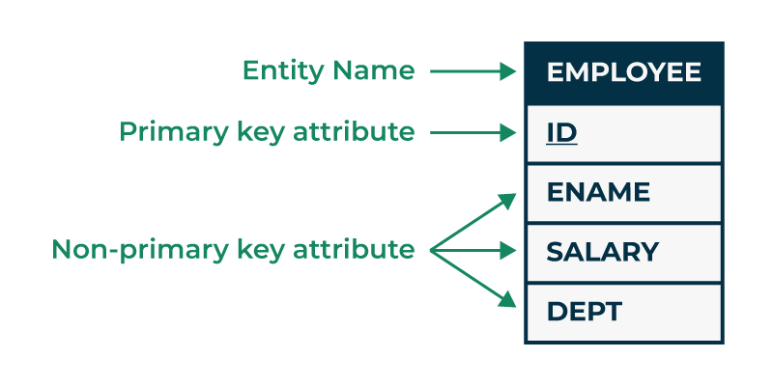

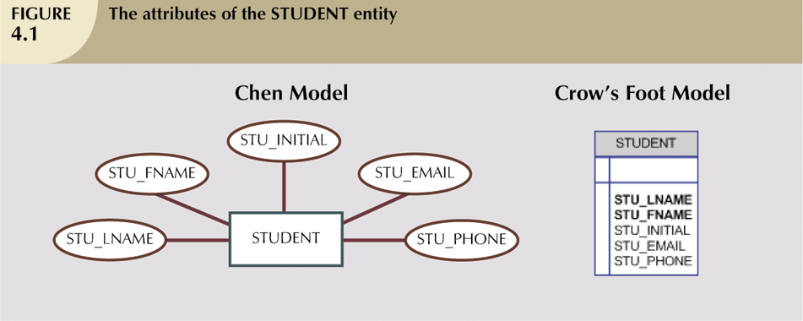

## **Domains**

* Domain is a set of values that can be stored in a column of a database table
* Attributes have domain.
  + Domain is attribute’s set of possible values.
* Attributes may share a domain.

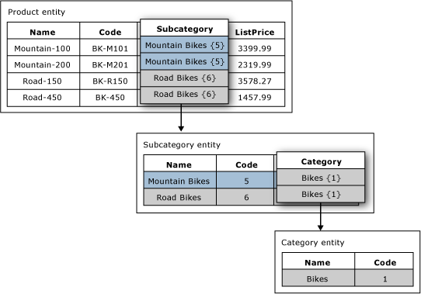

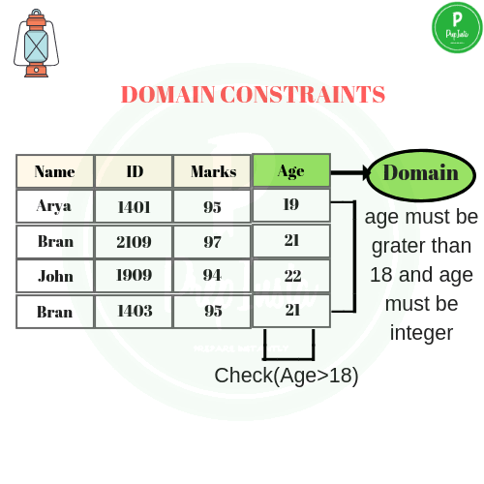

## **Identifiers (Primary Keys)**

* Primary keys ideally composed of only single attribute.
* Possible to use a composite key.
  + Primary key composed of more than one attribute.

Composite Primary Keys

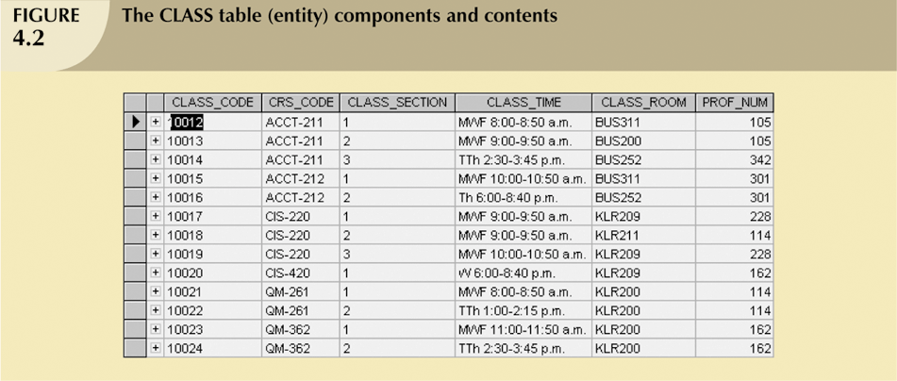

* Composite attributes can be subdivided.
* Simple attributes cannot be subdivided.
* Single-value attributes can have only a single value.
* Multivalued attributes can have many values.

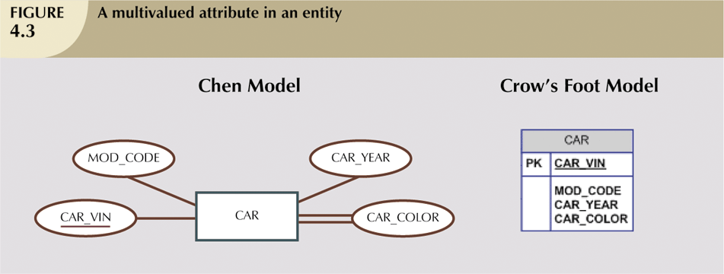

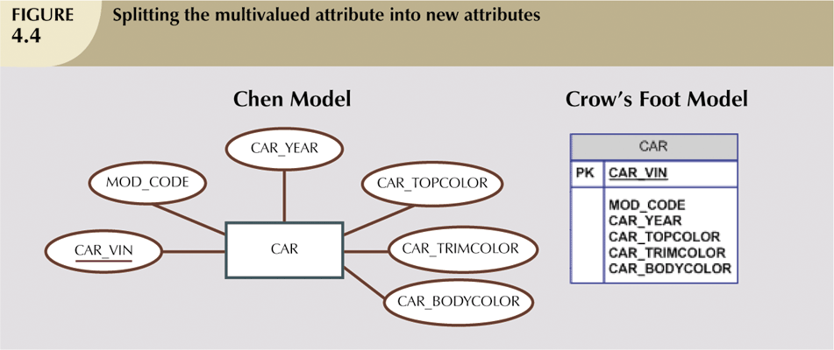

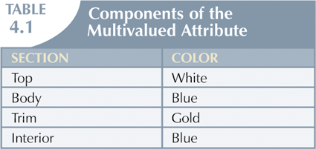 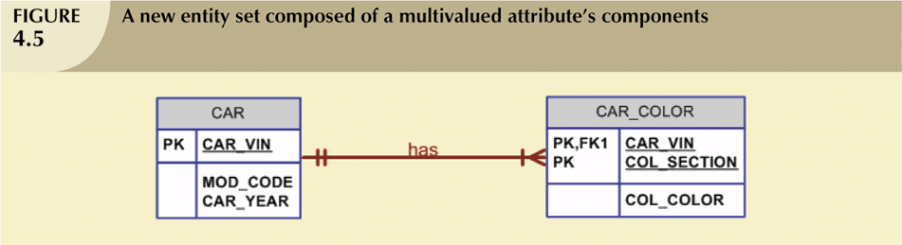

## **Derived Attributes**

* Attribute whose value may be calculated (derived) from other attributes.
* Need not be physically stored within database.
* Can be derived by using an algorithm.

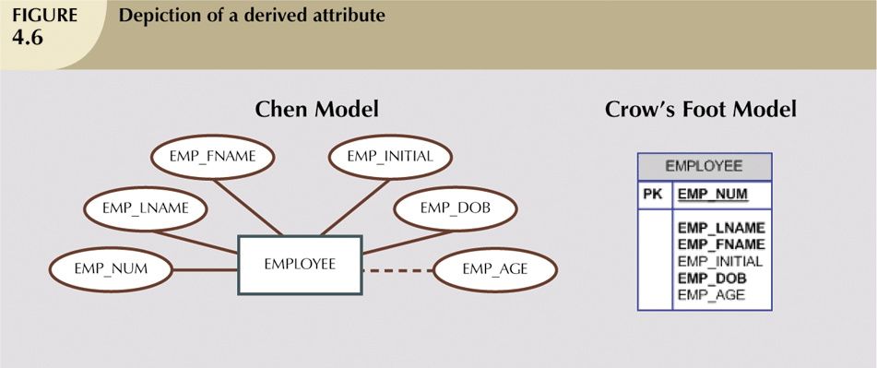

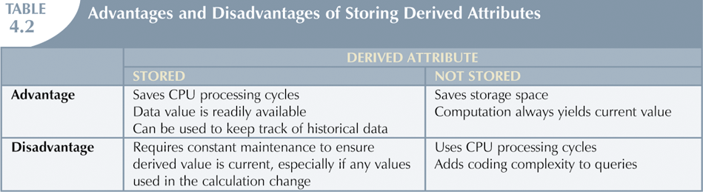

## **Relationships**

* Association between entities
* Participants are entities that participate in a relationship.
* Relationships between entities always operate in both directions.
* Relationship can be classified as 1:M.
* Relationship classification is difficult to establish if know only one side of the relationship.

## **Connectivity and Cardinality**

* Connectivity
  + Used to describe the relationship classification.
* Cardinality
  + Expresses minimum and maximum number of entity occurrences associated with one occurrence of related entity.
* Established by very concise statements known as business rules.

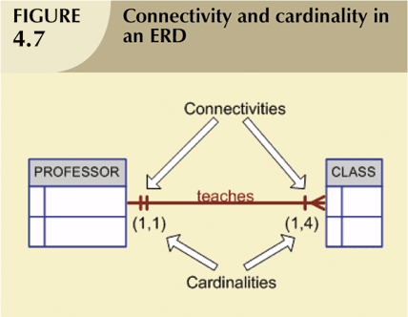

## **Weak Entity**

* Weak entity meets two conditions.
  + Existence-dependent
    - Cannot exist without entity with which it has a relationship.
  + Has primary key that is partially or totally derived from parent entity in relationship.
* Database designer usually determines whether an entity can be described as weak based on business rules.

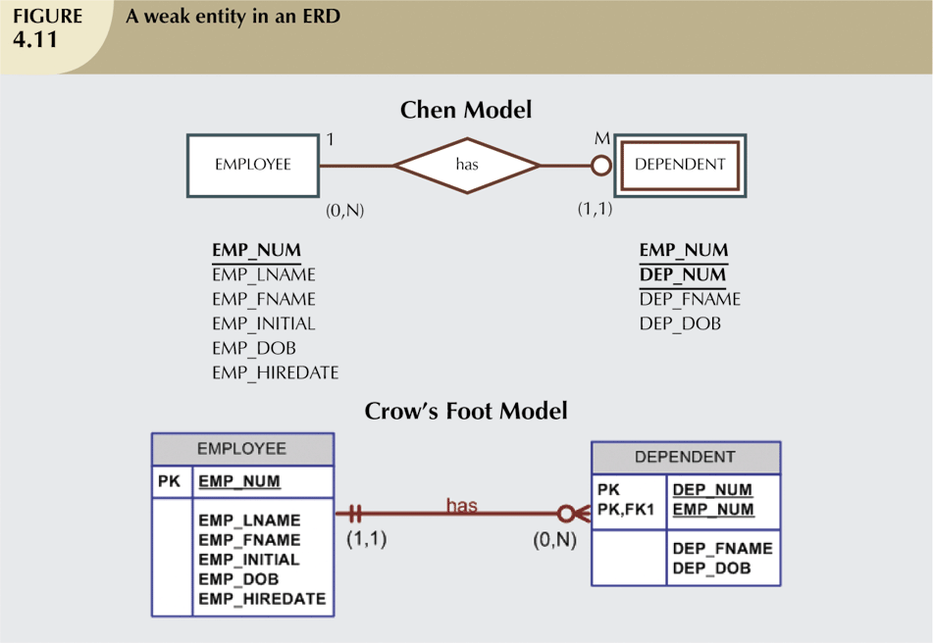

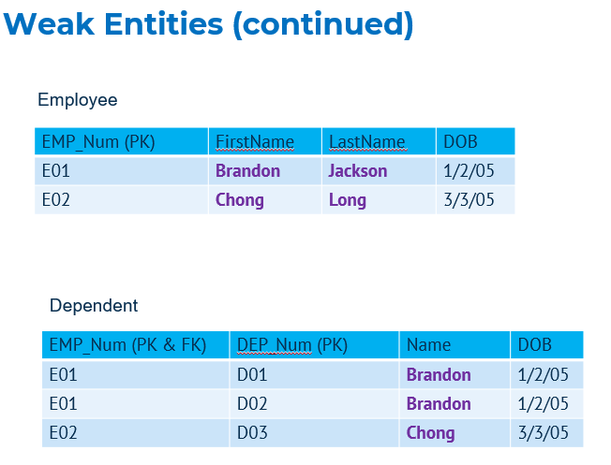

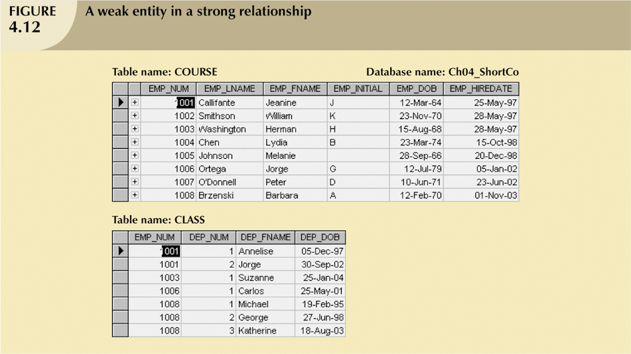

## **Q & A**

* Provide 1 example of derived attribute
* Provide 1 example of weak entity
* Provide 1 example of single-value attribute
* Provide 1 example of multi-value attribute

## **Summary**

* Derived attribute
* Weak entity
* Simple attribute vs composite attribute
* Single-value attribute vs multi-value attribute

# Chapter 7: Entity Relationship Model (part 2)

* + **Determine the relationship between entities.**
  + **Construct an entity relational model based on a case study.**

Topics to master:

* + **Crow’s foot**
  + **Chen’s model**
  + **Unary / recursive relationship**
  + **Binary relationship**
  + **Ternary relationship**
  + **Quaternary relationship**

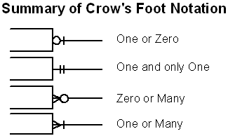

## **Relationship Participation**

* Optional participation
  + One entity occurrence does not require corresponding entity occurrence in particular relationship.
* Mandatory participation
  + One entity occurrence requires corresponding entity occurrence in particular relationship.

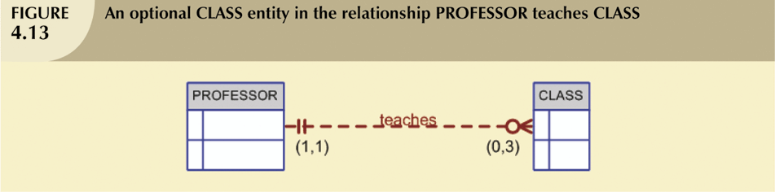

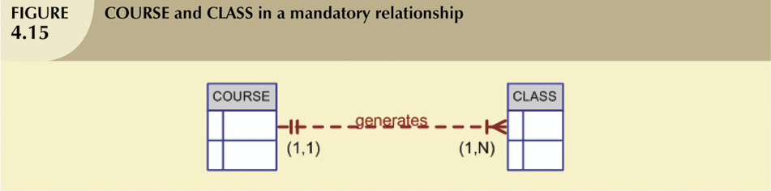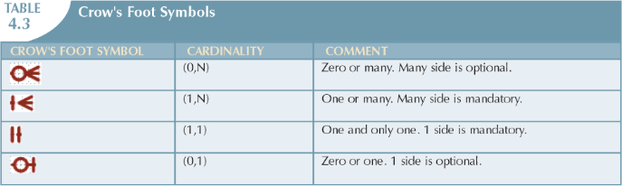

## **Relationship Degree**

* Indicates number of entities or participants associated with a relationship.
* Unary relationship
  + Association is maintained within single entity.
* Binary relationship
  + Two entities are associated.
* Ternary relationship
  + Three entities are associated.
* Quaternary relationship
  + Four entities are associated.

Unary relationship

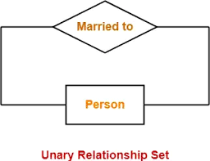

Binary Relationship called POwns



Ternary Relationship called Registers.

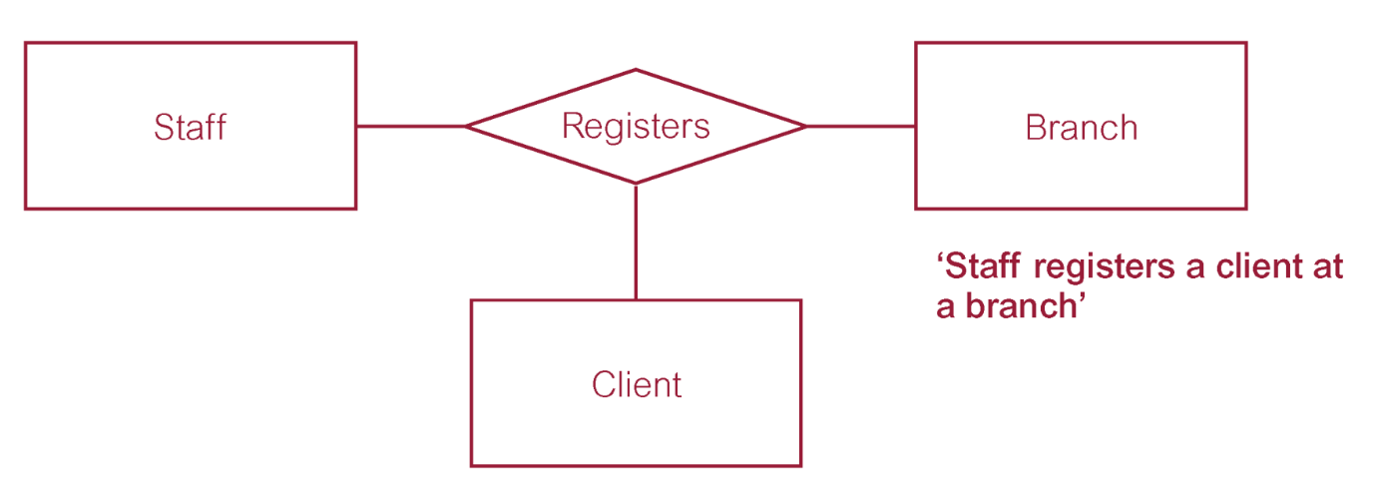

Quaternary relationship called Arranges.

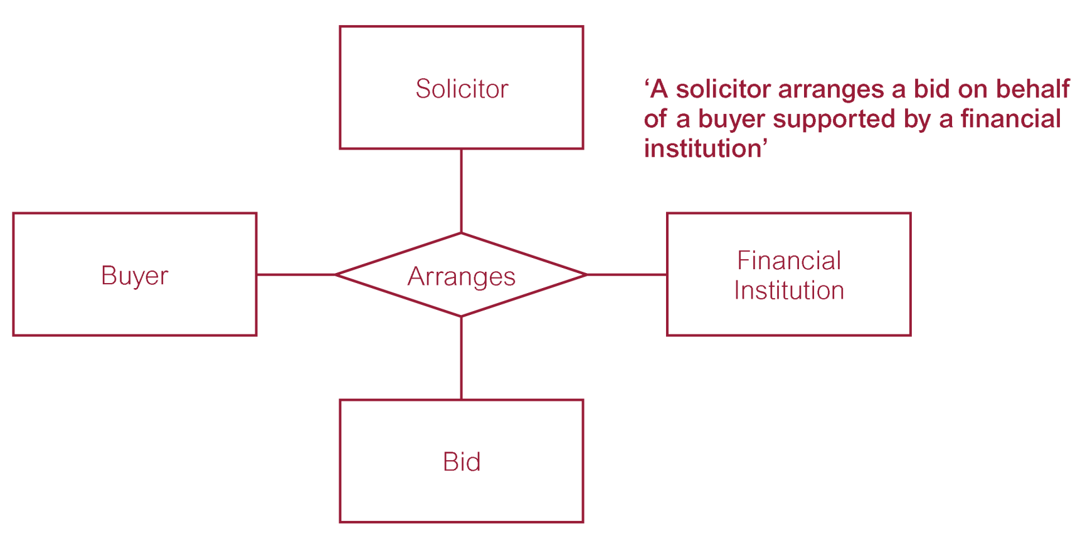

## **Recursive Relationships**

* Relationships can exist between occurrences of the same entity set.
* Naturally found within unary relationship.

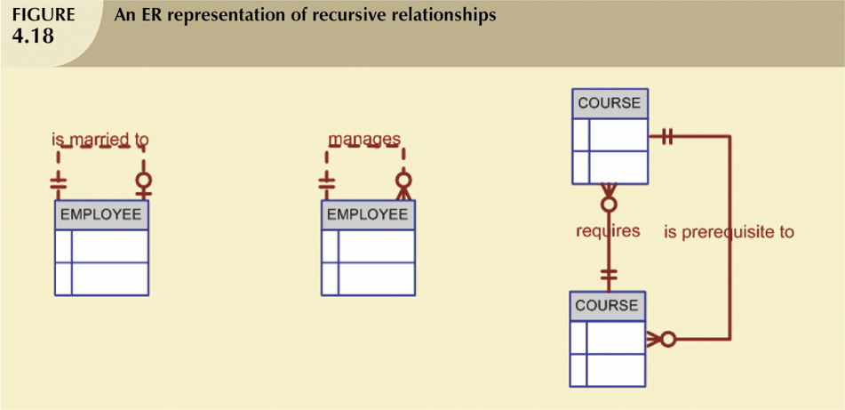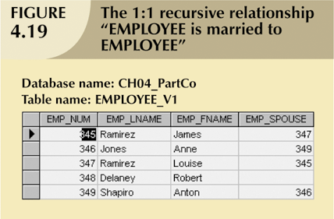

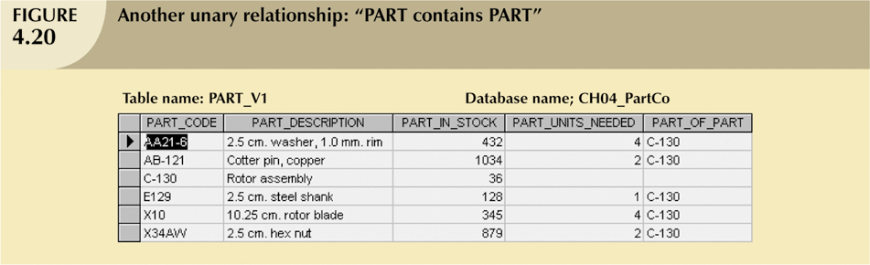

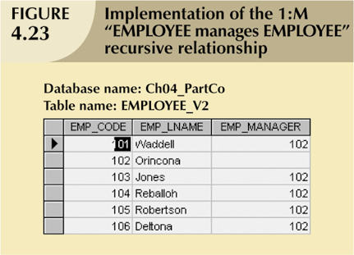

## **Composite Entities**

* Also known as bridge entities.
* Composed of primary keys of each of the entities to be connected.
* May also contain additional attributes that play no role in connective process.

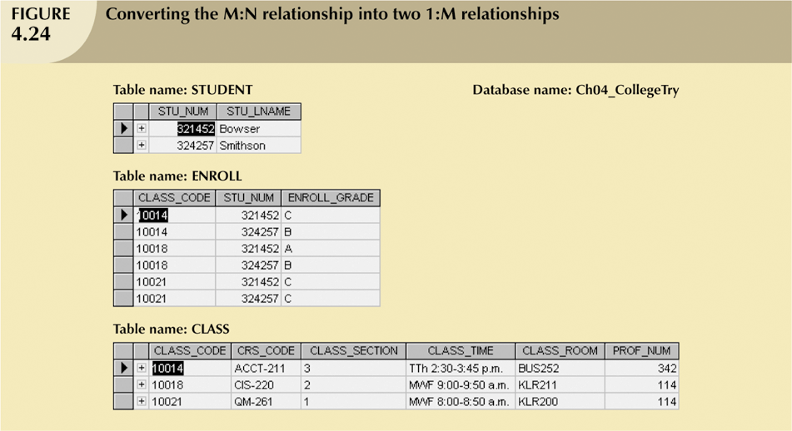

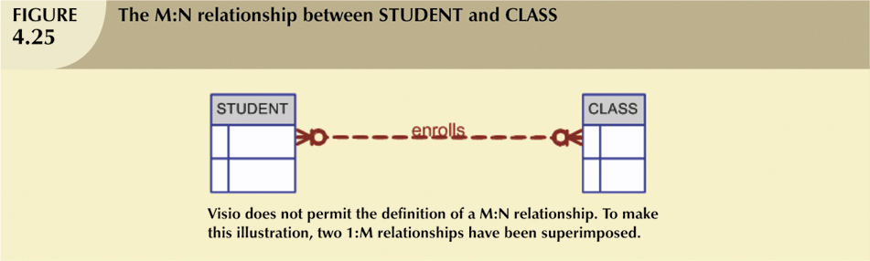

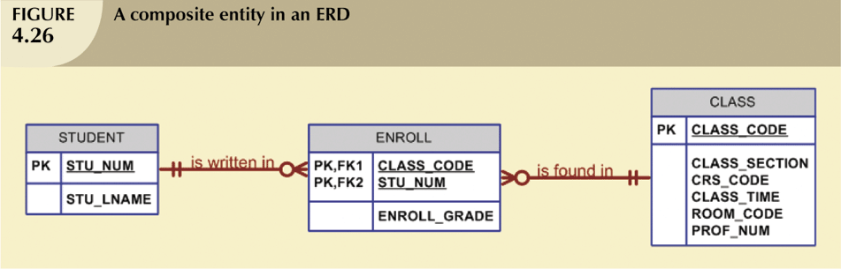

## **Q & A**

* Provide 1 example each for the relationship degree below
  + **Unary / recursive**
  + **Binary**
  + **Ternary**
  + **Quaternary**

Unary / Recursive Relationship (Degree 1):

This type of relationship involves a single entity set where an instance relates to itself in different roles.

Example: Social Media Network: In a social media platform, a user can follow other users. Here, the "User" entity has a relationship with itself, where one user can follow another. The follower and the followed user are both instances of the "User" entity.

Binary Relationship (Degree 2):

This type of relationship involves two distinct entity sets participating in an association.

Example: University Enrollment: A student enrolls in a course. Here, "Student" and "Course" are two separate entities, and the enrollment process establishes a connection between them.

Ternary Relationship (Degree 3):

This type of relationship involves three distinct entity sets participating in a single association.

Example: Movie Database: An actor acts in a movie directed by a director. Here, "Actor," "Movie," and "Director" are three distinct entities. The relationship involves all three entities to represent the participation of an actor in a movie directed by a specific director.

Quaternary Relationship (Degree 4):

This type of relationship involves four distinct entity sets participating in a single association. These are less common but can exist in complex scenarios.

Example: Car Rental: A customer rents a car from a company at a specific location for a certain duration. Here, "Customer," "Car," "Rental Company," and "Location" are four distinct entities. The car rental process establishes a connection between all four for a specific instance.

## **Summary**

* Entity relationship (ER) model
  + Uses ERD to represent conceptual database as viewed by end user.
  + Includes connectivity and cardinality notations.
* Connectivities and cardinalities are based on business rules.
* In ERM, M:N relationship is valid at conceptual level

# Chapter 8: Database Normalization

* Functional dependency
* Un-Normalized form
* First normal form
* Second normal form
* Third normal form

Topics to master:

* + **UNF**
  + **1NF**
  + **2NF**
  + **3NF**
  + **Partial dependency**
  + **Transitive dependency**

## **Normalization**

* Normalization
  + Process for evaluating and correcting table structures to minimize data redundancies
    - Reduces data anomalies
  + Works through a series of stages called normal forms:
    - First normal form (1NF)
    - Second normal form (2NF)
    - Third normal form (3NF)
* Normalization (continued)
  + 2NF is better than 1NF; 3NF is better than 2NF
  + For most business database design purposes, 3NF is as high as we need to go in normalization process
  + Highest level of normalization is not always most desirable
* Example: Company that manages building projects
  + Charges its clients by billing hours spent on each contract
  + Hourly billing rate is dependent on employee’s position
  + Periodically, report is generated that contains information displayed in Table 5.1

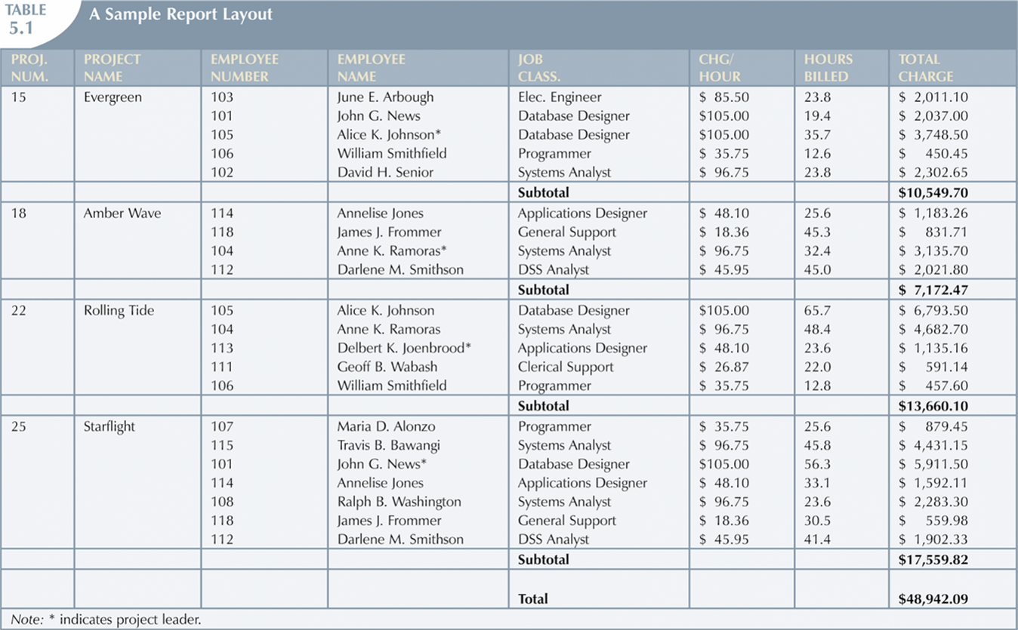

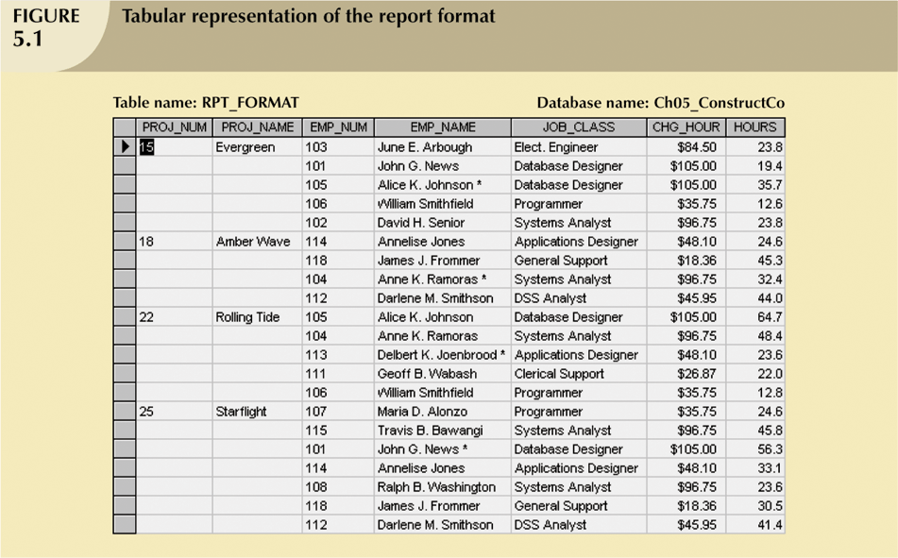

* Structure of data set in Figure 5.1 does not handle data very well.
* The table structure appears to work; report generated with ease.
* Unfortunately, report may yield different results depending on what data anomaly has occurred.
* Each table represents a single subject.
* No data item will be unnecessarily stored in more than one table.
* All attributes in a table are dependent on the primary key.

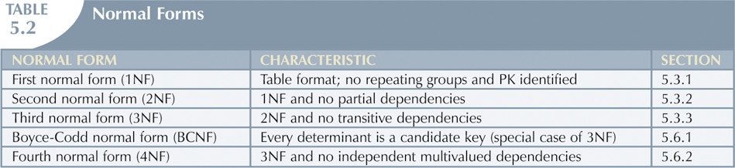

## **1NF**

* Repeating group
  + Derives its name from the fact that a group of multiple entries of same type can exist for any single key attribute occurrence.
* Relational table must not contain repeating groups.
* Normalizing table structure will reduce data redundancies.
* Normalization is three-step procedure.

Step 1: Eliminate the Repeating Groups

* + Present data in tabular format, where each cell has single value and there are no repeating groups.
  + Eliminate repeating groups, eliminate nulls by making sure that each repeating group attribute contains an appropriate data value.

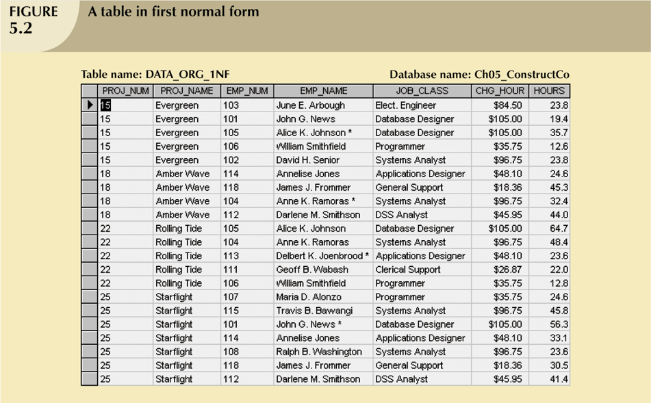

Step 2: Identify the Primary Key

* + Primary key must uniquely identify attribute value
  + New key must be composed

Step 3: Identify All Dependencies

* + Dependencies can be depicted with help of a diagram
  + Dependency diagram:
    - Depicts all dependencies found within given table structure.
    - Helpful in getting bird’s-eye view of all relationships among table’s attributes.
    - Makes it less likely that will overlook an important dependency.
* First normal form describes tabular format in which:
  + All key attributes are defined.
  + There are no repeating groups in the table.
  + All attributes are dependent on primary key.
* All relational tables satisfy 1NF requirements.
* Some tables contain partial dependencies.
  + Dependencies based on only part of the primary key.
  + Sometimes used for performance reasons, but should be used with caution.
  + Still subject to data redundancies

## **2NF**

* Relational database design can be improved by converting the database into second normal form (2NF)
* Two steps

Step 1: Write Each Key Component   
on a Separate Line

* Write each key component on separate line, then write original (composite) key on last line.
* Each component will become key in new table.

Step 2: Assign Corresponding Dependent Attributes

* Determine those attributes that are dependent on other attributes.
* At this point, most anomalies have been eliminated.

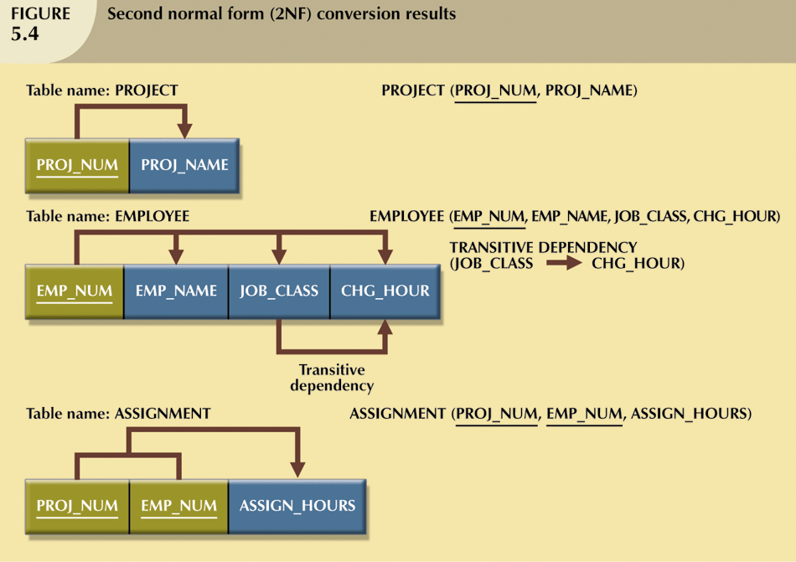

* Table is in second normal form (2NF) when:
  + It is in 1NF and
  + It includes no partial dependencies:
    - No attribute is dependent on only portion of primary key

## **3NF**

* Data anomalies created are easily eliminated by completing three steps

Step 1: Identify Each New Determinant

* For every transitive dependency, write its determinant as PK for new table
  + - Determinant
      * Any attribute whose value determines other values within a row.

Step 2: Identify the Dependent Attributes

* + Identify attributes dependent on each determinant identified in Step 1 and identify dependency.
  + Name table to reflect its contents and function.

Step 3: Remove the Dependent Attributes from Transitive Dependencies

* + Eliminate all dependent attributes in transitive relationship(s) from each of the tables that have such a transitive relationship.
  + Draw new dependency diagram to show all tables defined in Steps 1–3
  + Check new tables as well as tables modified in Step 3 to make sure that each table has determinant and that no table contains inappropriate dependencies.

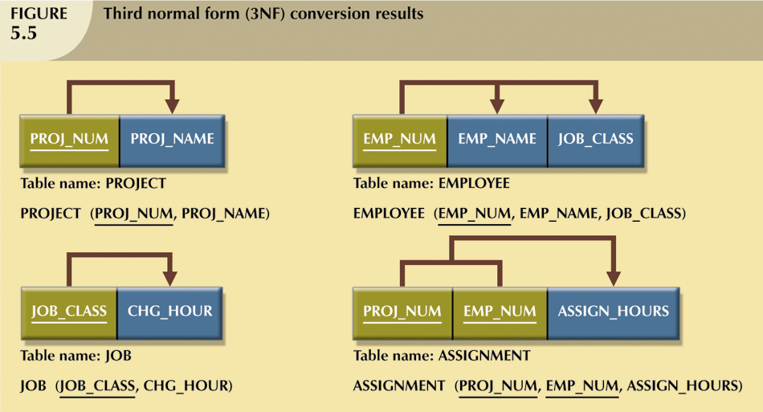

* A table is in third normal form (3NF) when both of the following are true:
  + It is in 2NF.
  + It contains no transitive dependencies.

## **Q & A**

1. What is partial dependency?
2. What is transitive dependency?

**1) Partial Dependency:**

In relational databases, a partial dependency occurs when a non-prime attribute (attribute not part of the primary key) is determined by only a part of the candidate key (possible primary key). This means a non-key attribute relies on a subset of the primary key to uniquely identify a record.

Here's a breakdown:

Non-prime attribute: An attribute in the table that is not part of the primary key.

Candidate key: A set of attributes that uniquely identifies each record in a table. There can be multiple candidate keys for a table.

Partial dependency: A non-prime attribute depends on only a part of the candidate key, not the entire key.

Example:

Consider a table storing student information with columns: StudentID (primary key), Name, Major, and Department.

In this example, if the table allows departments to have multiple majors, then "Major" might have a partial dependency on "Department." This is because all students within a specific department might have the same major, but "Major" itself doesn't uniquely identify a student (it depends on knowing the department as well).

Problems with Partial Dependency:

Partial dependencies can lead to data redundancy and inconsistencies during updates or deletions. Normalization techniques in database design aim to eliminate partial dependencies, ensuring a well-structured and efficient database.

**2) Transitive Dependency:**

A transitive dependency occurs when a non-prime attribute is determined by another non-prime attribute, which in turn is determined by the primary key. It's like a chain reaction of dependencies.

Here's how it works:

Non-prime attribute: Similar to partial dependency, it's an attribute not part of the primary key.

Example:

Consider a table storing order information with columns: OrderID (primary key), CustomerID, ProductID, and Price.

If the table also stores "CustomerID" and "ProductID" separately, a transitive dependency might exist.

"Price" might depend on "ProductID" (knowing the product reveals the price).

"ProductID" might depend on "CustomerID" (assuming customers have preferred products).

In this case, "Price" ultimately depends on "CustomerID" indirectly through "ProductID." This is a transitive dependency.

Problems with Transitive Dependency:

Similar to partial dependency, transitive dependencies can lead to data redundancy and update/deletion anomalies. Normalization techniques help eliminate these dependencies for a more efficient and reliable database.

# Chapter 9: SQL

* Basic commands and functions of SQL
* SQL for data administration
* SQL for data manipulation
* SQL to query a database

Topics to master:

* + **Create**
  + **Insert**
  + **Update**
  + **Delete**
  + **Select**

## Introduction to SQL

* SQL functions fit into two broad categories:
  + Data definition language
    - SQL includes commands to:
      * Create database objects, such as tables, indexes, and views.
      * Define access rights to those database objects.
  + Data manipulation language
    - Includes commands to insert, update, delete, and retrieve data within database tables.
* SQL is relatively easy to learn
* Basic command set has vocabulary of less than 100 words
* Nonprocedural language
* American National Standards Institute (ANSI) prescribes a standard SQL
* Several SQL dialects exist

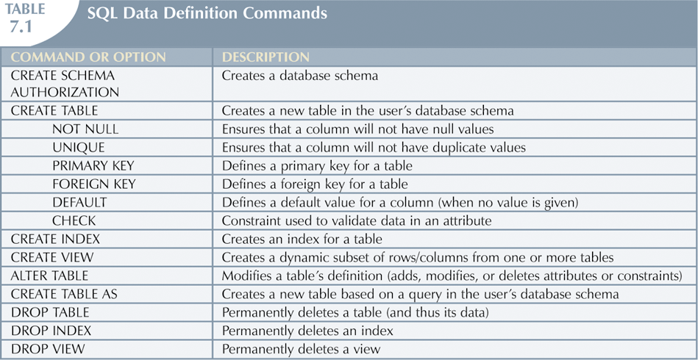

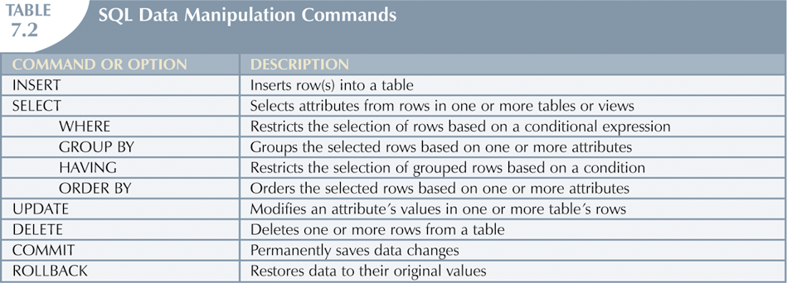

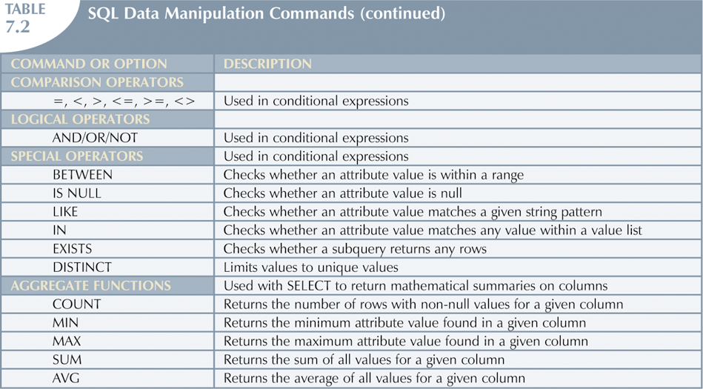

## **Data Definition Commands**

* Examine simple database model and database tables that will form basis for many SQL examples.
* Understand data environment.

## **Database Model**

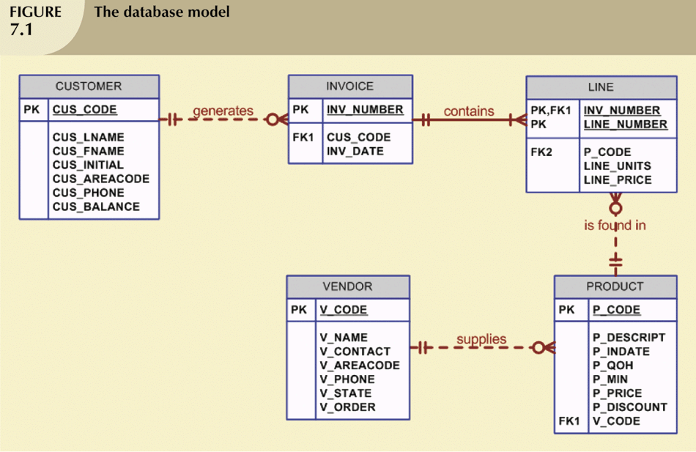

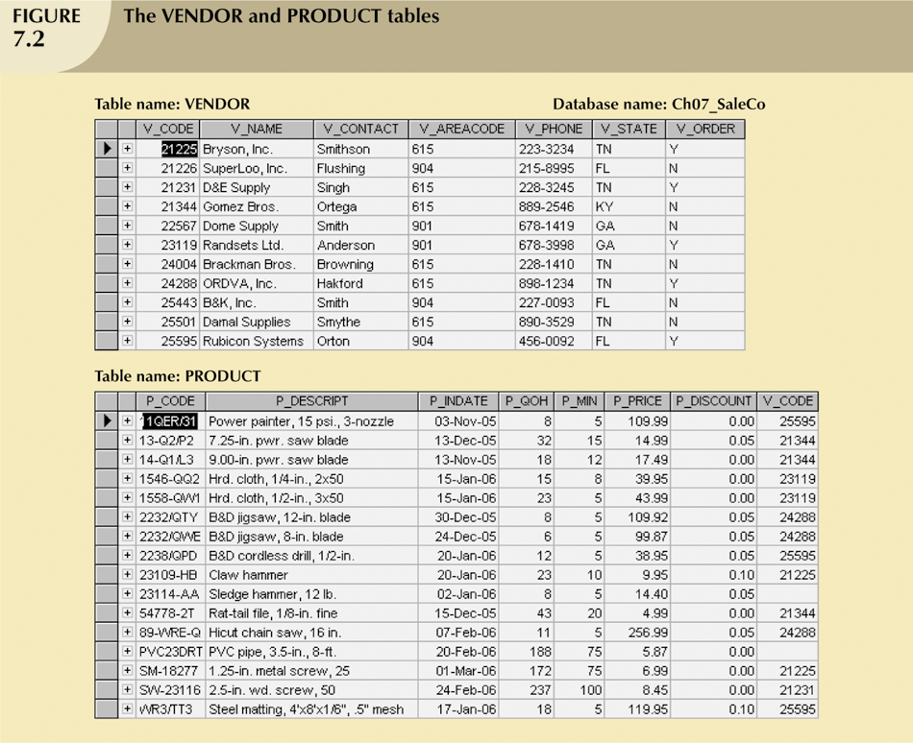

## **Creating Database**

* Following two tasks must be completed:
  + Create database structure.
  + Create tables that will hold end-user data.
* First task:
  + RDBMS creates physical files that will hold database.
  + Tends to differ substantially from one RDBMS to another.

## **Database Schema**

* Authentication
  + Process through which DBMS verifies that only registered users are able to access database.
  + Log on to RDBMS using user ID and password created by database administrator.
* Schema
  + Group of database objects—such as tables and indexes—that are related to each other.

## **Data Types**

* Data type selection is usually dictated by nature of data and by intended use.
* Pay close attention to expected use of attributes for sorting and data retrieval purposes.

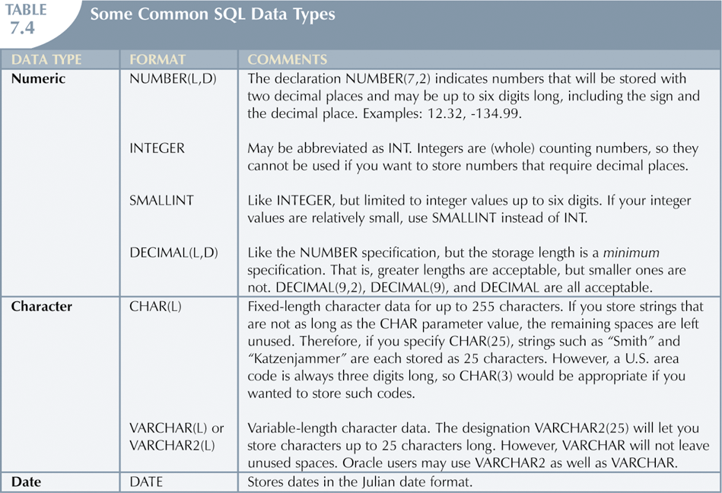

## **Creating Table Structures**

* Primary key attributes contain both a NOT NULL and a UNIQUE specification.
* RDBMS will automatically enforce referential integrity for foreign keys.
* Command sequence ends with semicolon.

## **SQL Constrains**

* NOT NULL constraint
  + Ensures that column does not accept nulls
* UNIQUE constraint
  + Ensures that all values in column are unique
* DEFAULT constraint
  + Assigns value to attribute when a new row is added to table
* CHECK constraint
  + Validates data when attribute value is entered

## **Data Manipulation Commands**

* Adding table rows
* Saving table changes
* Listing table rows
* Updating table rows
* Restoring table contents
* Deleting table rows
* Inserting table rows with a select subquery

## **Adding table rows**

* INSERT
  + Used to enter data into table
  + Syntax:
    - INSERT INTO *columnname*  
      VALUES (*value1, value2, … , valuen*);
* When entering values, notice that:
  + Row contents are entered between parentheses [()].
  + Character and date values are entered between apostrophes [‘].
  + Numerical entries are not enclosed in apostrophes [‘].
  + Attribute entries are separated by commas.
  + A value is required for each column.
* Use NULL for unknown values.

## **Saving Table Changes**

* Changes made to table contents are not physically saved on disk until, one of the following occurs:
  + Database is closed.
  + Program is closed.
  + COMMIT command is used.
* Syntax:
  + COMMIT [WORK];
* Will permanently save any changes made to any table in the database.
* SELECT
  + Used to list contents of table
  + Syntax:
    - SELECT *columnlist*  
      FROM *tablename*;
* *Columnlist* represents one or more attributes, separated by commas.
* Asterisk can be used as wildcard character to list all attributes.

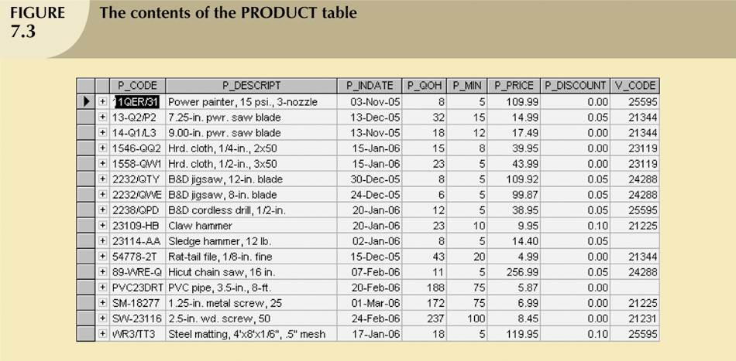

## **Updating Table Rows**

* UPDATE
  + Modify data in a table.
  + Syntax:
    - UPDATE *tablename*  
      SET *columnname* = *expression* [, *columname* = *expression*]  
      [WHERE *conditionlist*];
* If more than one attribute is to be updated in row, separate corrections with commas.

## **Restoring Tables Contents**

* ROLLBACK
  + Used to restore database to its previous condition.
  + Only applicable if COMMIT command has not been used to permanently store changes in database.
* Syntax:
  + ROLLBACK;
* COMMIT and ROLLBACK only work with data manipulation commands that are used to add, modify, or delete table rows.

## **Deleting Table Rows**

* DELETE
  + Deletes a table row.
  + Syntax:
    - DELETE FROM *tablename*  
      [WHERE *conditionlist* ];
* WHERE condition is optional
* If WHERE condition is not specified, all rows from specified table will be deleted.

## **Inserting Table with Subquery**

* INSERT
  + Inserts multiple rows from another table (source)
  + Uses SELECT subquery.
    - Query that is embedded (or nested) inside another query.
    - Executed first.
  + Syntax:
    - INSERT INTO *tablename* SELECT *columnlist* FROM *tablename*;

## **Selecting Rows with Conditional Restrictions**

* Select partial table contents by placing restrictions on rows to be included in output.
  + Add conditional restrictions to SELECT statement, using WHERE clause
* Syntax:
  + SELECT *columnlist*  
    FROM *tablelist*  
    [ WHERE *conditionlist* ] ;

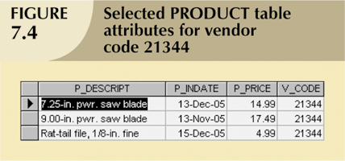

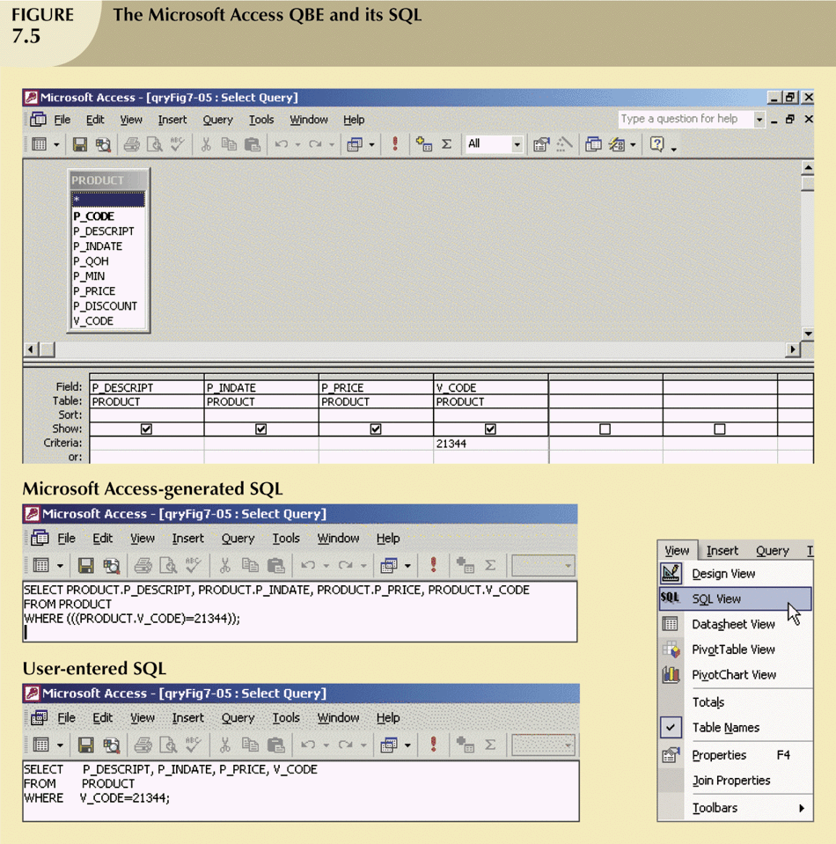

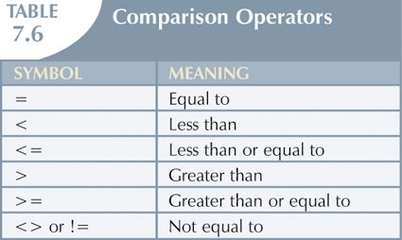

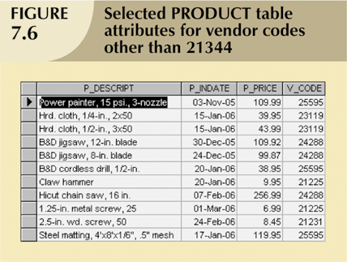

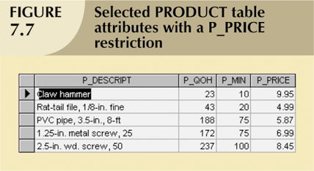

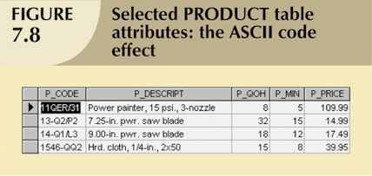

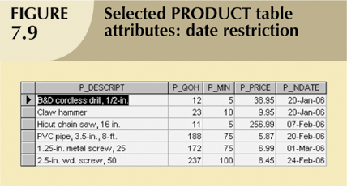

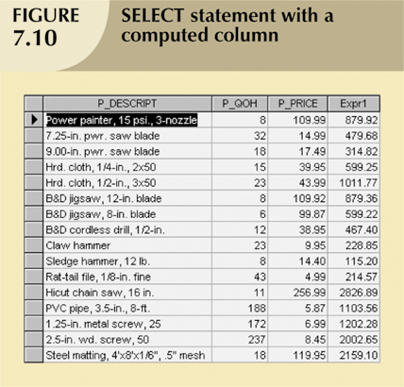

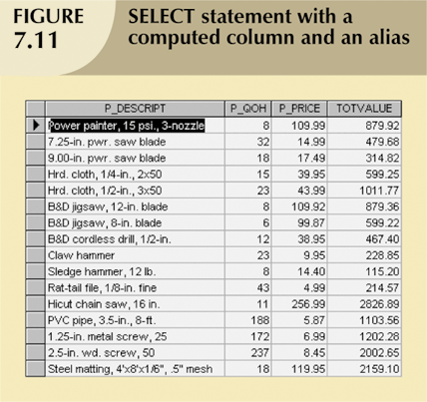

## **Arithmetic Operations**

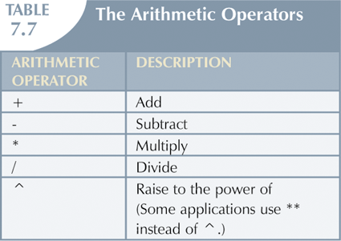

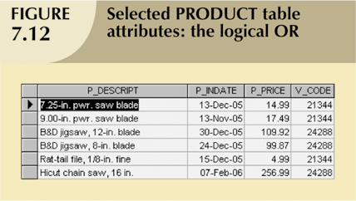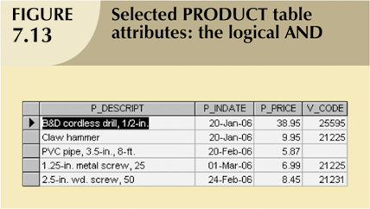

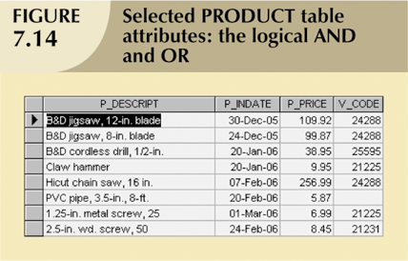

## **Special Operators**

* BETWEEN
  + Used to check whether attribute value is within a range.
* IS NULL
  + Used to check whether attribute value is null.
* LIKE
  + Used to check whether attribute value matches given string pattern.
* IN
  + Used to check whether attribute value matches any value within a value list.
* EXISTS
  + Used to check if subquery returns any rows.

## **Summary**

* DML commands allow you to add, modify, and delete rows from tables.
* The basic DML commands are SELECT, INSERT, UPDATE, DELETE, COMMIT, and ROLLBACK
* INSERT command is used to add new rows to tables.
* SELECT statement is main data retrieval command in SQL.

# Chapter 10: SQL (Joins)

* Aggregate functions
* Altering data type
* Grouping data
* Joining database

Topics to master:

* + **Alter**
  + **Modify**
  + **Drop**
  + **Group by**
  + **Order by**
  + **JOIN**
* All changes in table structure are made by using ALTER command
  + Followed by keyword that produces specific change
  + Following three options are available:
    - ADD
    - MODIFY
    - DROP

## **Changing a Column’s Data Type**

* ALTER can be used to change data type.
* Some RDBMSs (such as Oracle) do not permit changes to data types unless column to be changed is empty.
* Use ALTER to change data characteristics.
* If column to be changed already contains data, changes in column’s characteristics are permitted if those changes do not alter the data type.
* Use ALTER to add column (But doesn’t include NOT NULL clause for new column.
* Use ALTER to drop column.
  + Some RDBMSs impose restrictions on the deletion of an attribute.

## **Advance Data Updates**

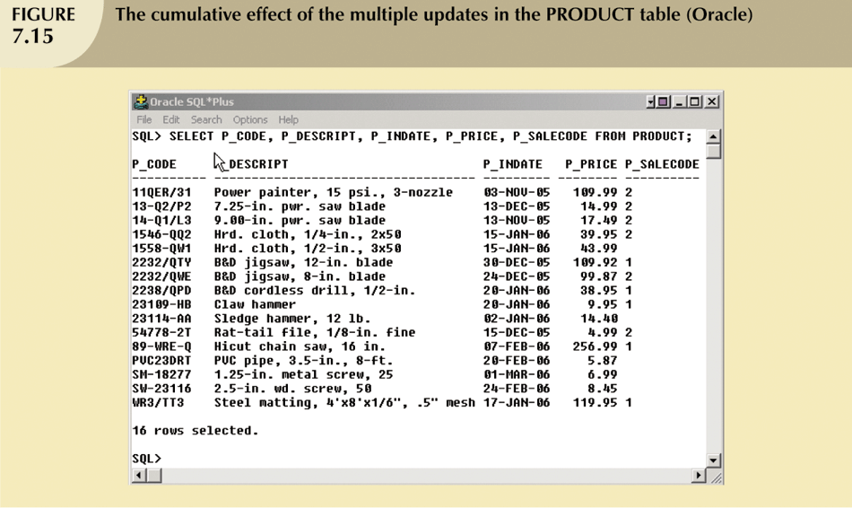

Copying Parts of Tables

* SQL permits copying contents of selected table columns so that the data need not be reentered manually into newly created table(s)
* First create the PART table structure
* Next add rows to new PART table using PRODUCT table rows

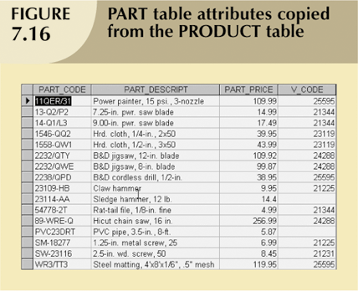

## **Aggregate Functions**

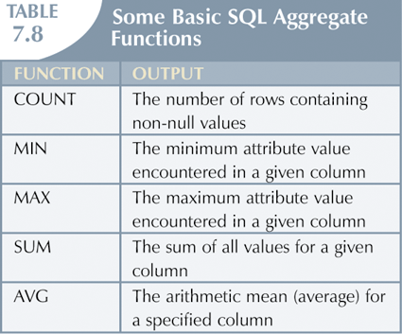

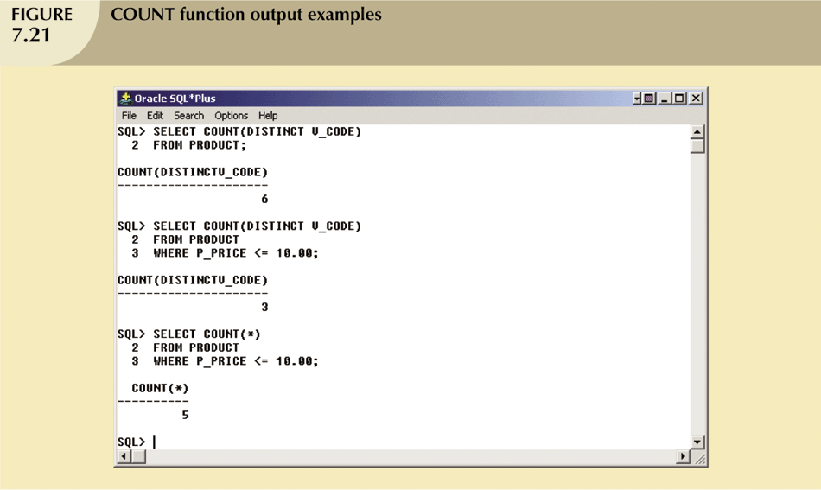

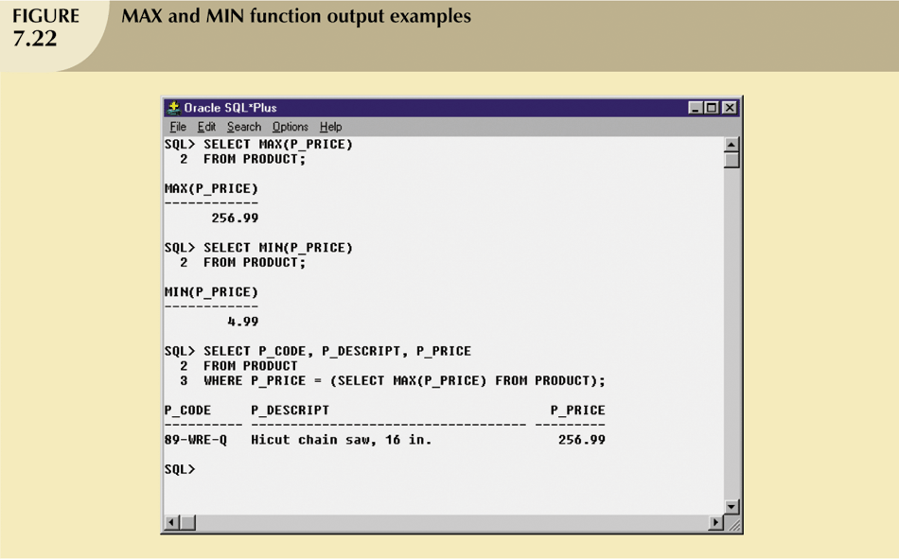

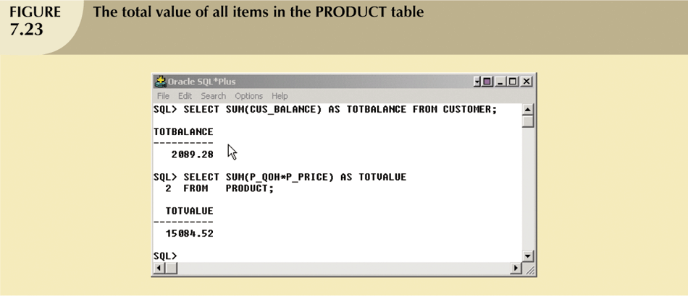

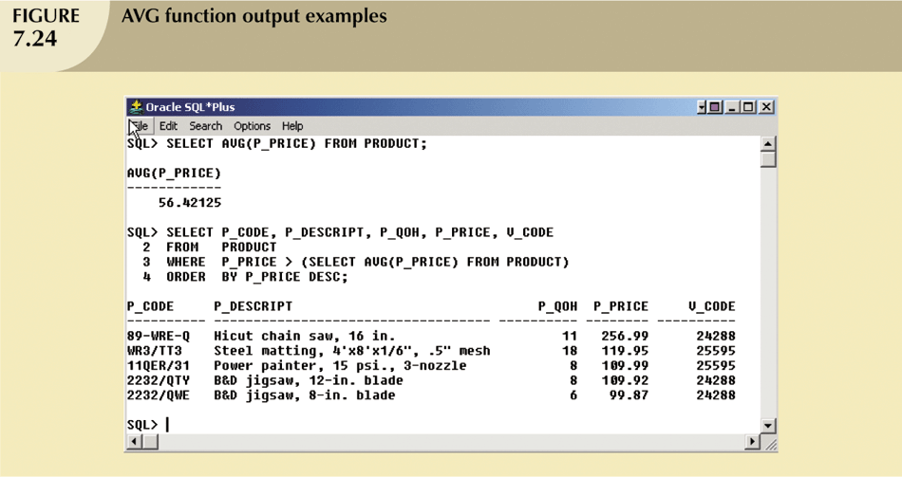

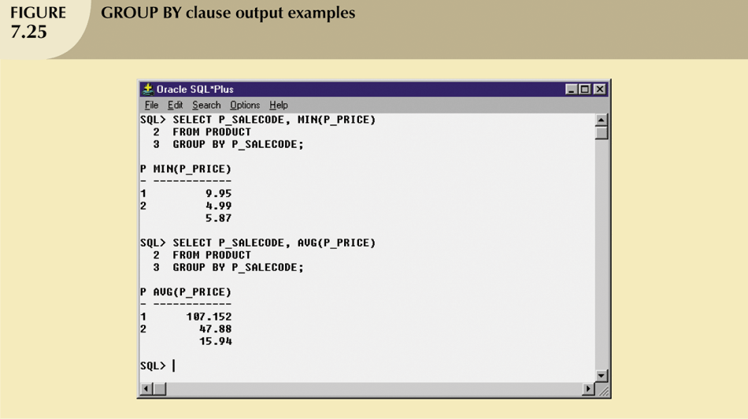

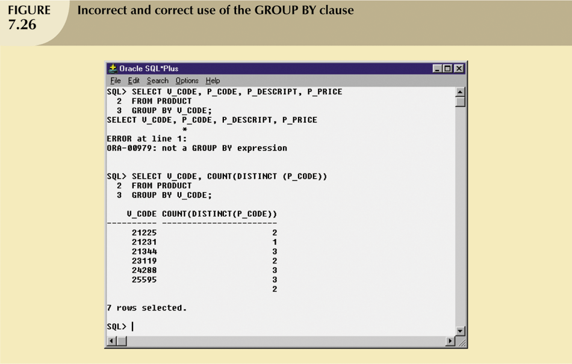

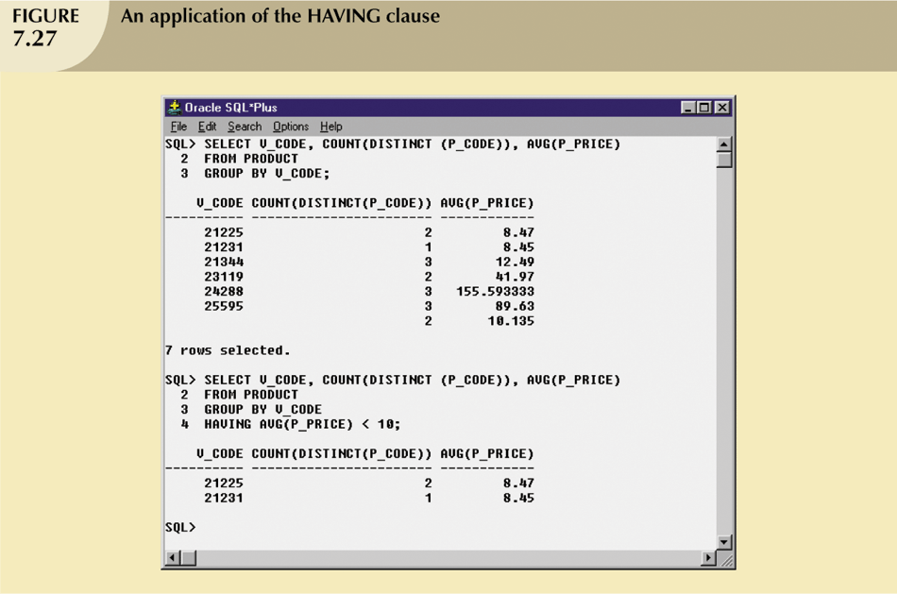

## **Creating a View**

* View is virtual table based on SELECT query.
  + Can contain columns, computed columns, aliases, and aggregate functions from one or more tables.
* Base tables are tables on which view is based .
* Create view by using CREATE VIEW command.

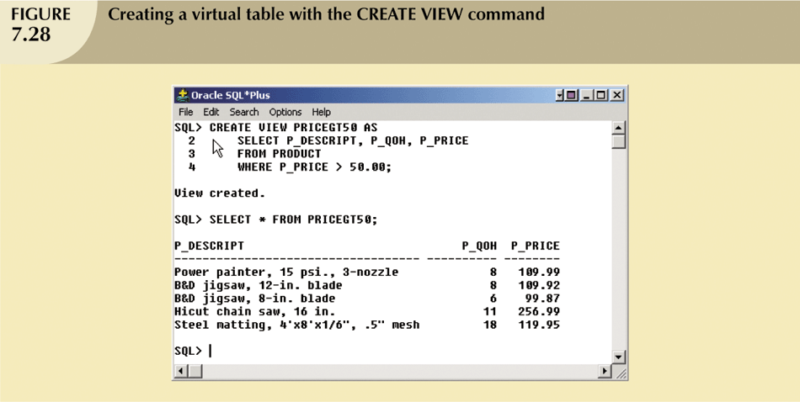

## **Joining Database Tables**

* Ability to combine (join) tables on common attributes is most important distinction between relational database and other databases.
* Join is performed when data are retrieved from more than one table at a time.
* Join is generally composed of an equality comparison between foreign key and primary key of related tables.

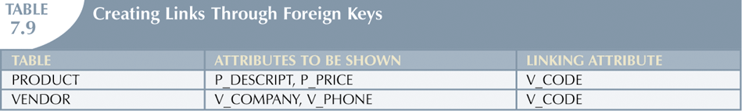

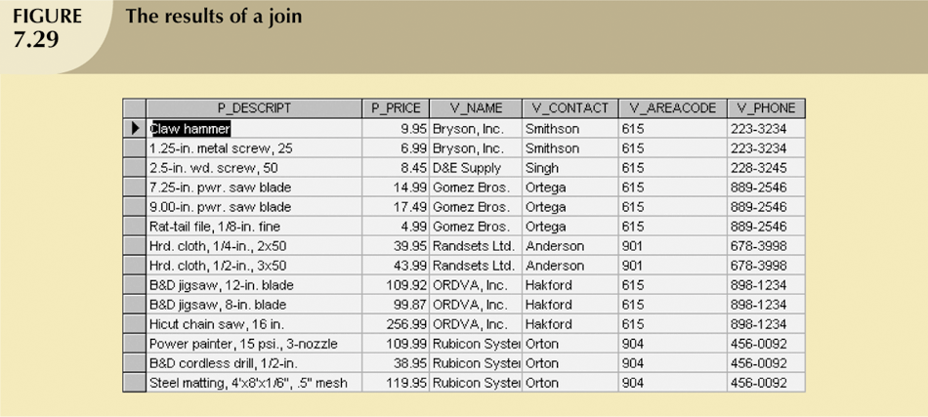

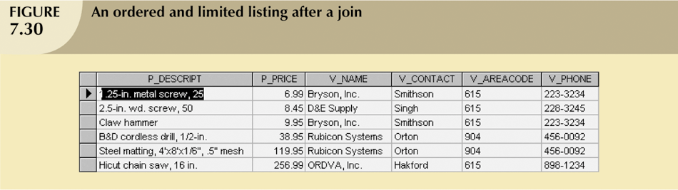

## **Joining Tables with an Alias**

* Alias can be used to identify source table.
* Any legal table name can be used as alias.
* Add alias after table name in FROM clause.
  + FROM *tablename alias*

Recursive Joins

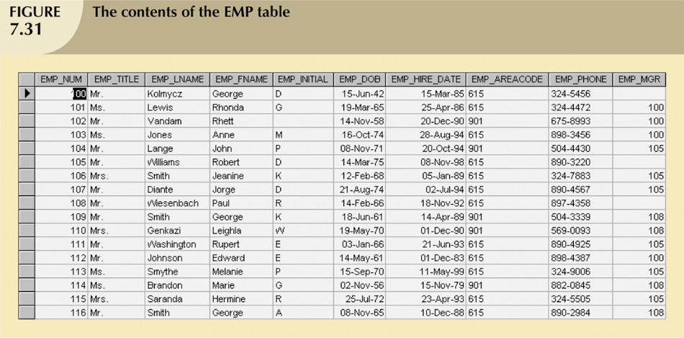

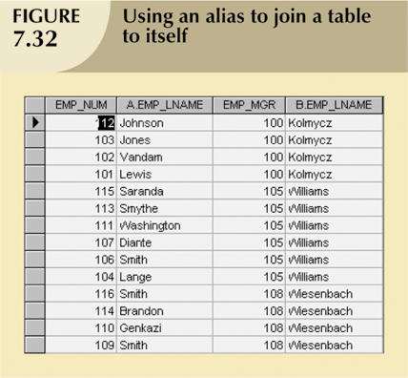

## **Outer Join**

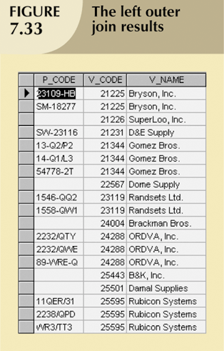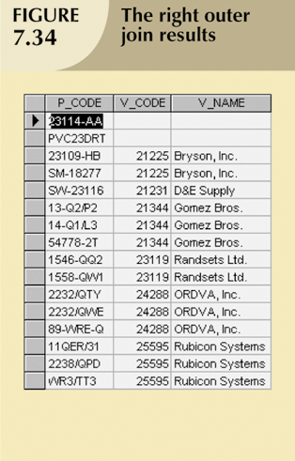

## **Q & A**

* State the difference between types of JOIN below
  1. Inner join
  2. Left join
  3. Right join
  4. Full join

1. **Inner Join:**

* **Matched Rows Only:** This is the most common JOIN type. It returns only rows where there's a matching value in both tables based on the join condition.
* **Example:** Find all orders (OrderID, CustomerID) with their corresponding customer names (CustomerID, Name) from separate tables. The inner join will only include rows where a customer ID exists in both tables.

1. **Left Join:**

* **All Left Table Rows:** This JOIN keeps all rows from the left table (specified before the LEFT JOIN keyword) regardless of whether there's a match in the right table. Unmatched rows in the right table will have NULL values in the corresponding columns.
* **Example:** Find all customers (CustomerID, Name) and their most recent orders (OrderID, CustomerID) from separate tables. Even if a customer has no recent orders, their information will be included with NULL in the order details.

1. **Right Join:**

* **All Right Table Rows:** Similar to left join, but it keeps all rows from the right table (specified after the RIGHT JOIN keyword) even if there's no match in the left table. Unmatched rows in the left table will have NULL values.
* **Example:** Find all products (ProductID, Name) and their current stock levels (ProductID, Quantity) from separate tables. Even if a product has no stock, it will be included with NULL in the quantity field.

1. **Full Join:**

* **All Rows from Both Tables:** This JOIN combines all rows from both tables, regardless of whether there's a match in the other table. Unmatched rows will have NULL values in the corresponding columns from the unmatched table.
* **Example:** Find all customers (CustomerID, Name) and all orders (OrderID, CustomerID) from separate tables, even if some customers have no orders and some orders have no matching customer information.

## **Summary**

* Aggregate functions
  + Special functions that perform arithmetic computations over a set of rows
* ORDER BY clause
  + Used to sort output of SELECT statement.
  + Can sort by one or more columns and use either an ascending or descending order.
* Join output of multiple tables with SELECT statement.
* Natural join uses join condition to match only rows with equal values in specified columns.
* Right outer join and left outer join used to select rows that have no matching values in other related table.